Dilation

Definition
# Source: AI Source: Provided by: [Data Path: Persons Table -> ID Column: 1, Name_En Column: Motasem Essam] -> From: [ChatGPT] on [7/25/2026]
Dilation is a geometric transformation that enlarges or reduces a figure by multiplying its dimensions by a constant scale factor relative to a fixed point called the center of dilation.
Unlike translation, rotation, and reflection, dilation can change the size of a figure.
A dilation preserves the:
- Shape
- Angle measures
- Proportions
but generally changes:
- Side lengths
- Perimeter
- Area
The original and dilated figures are therefore similar, but they are not necessarily congruent.
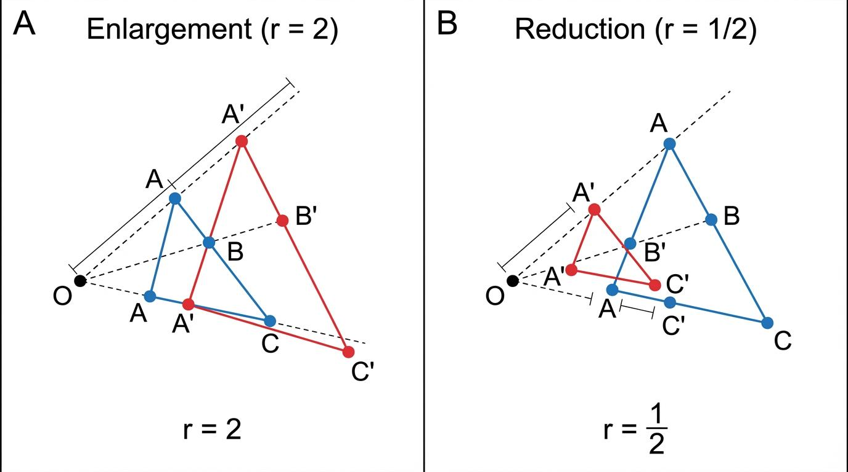
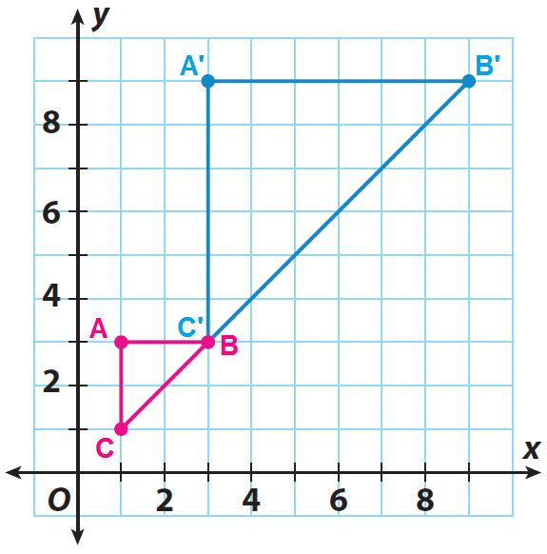
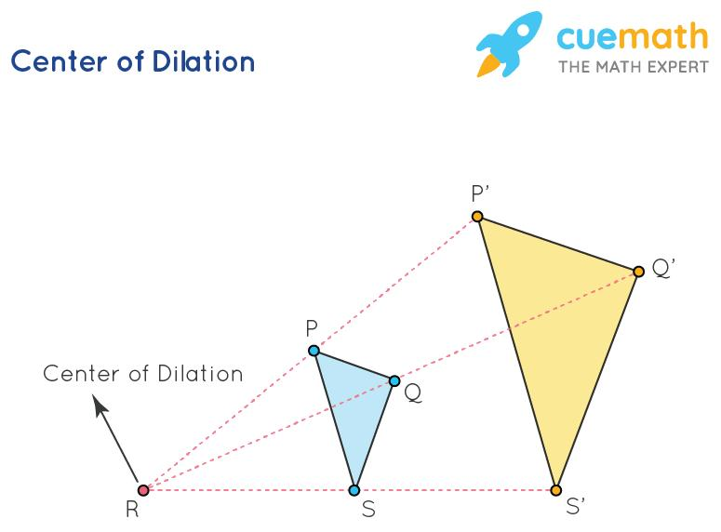
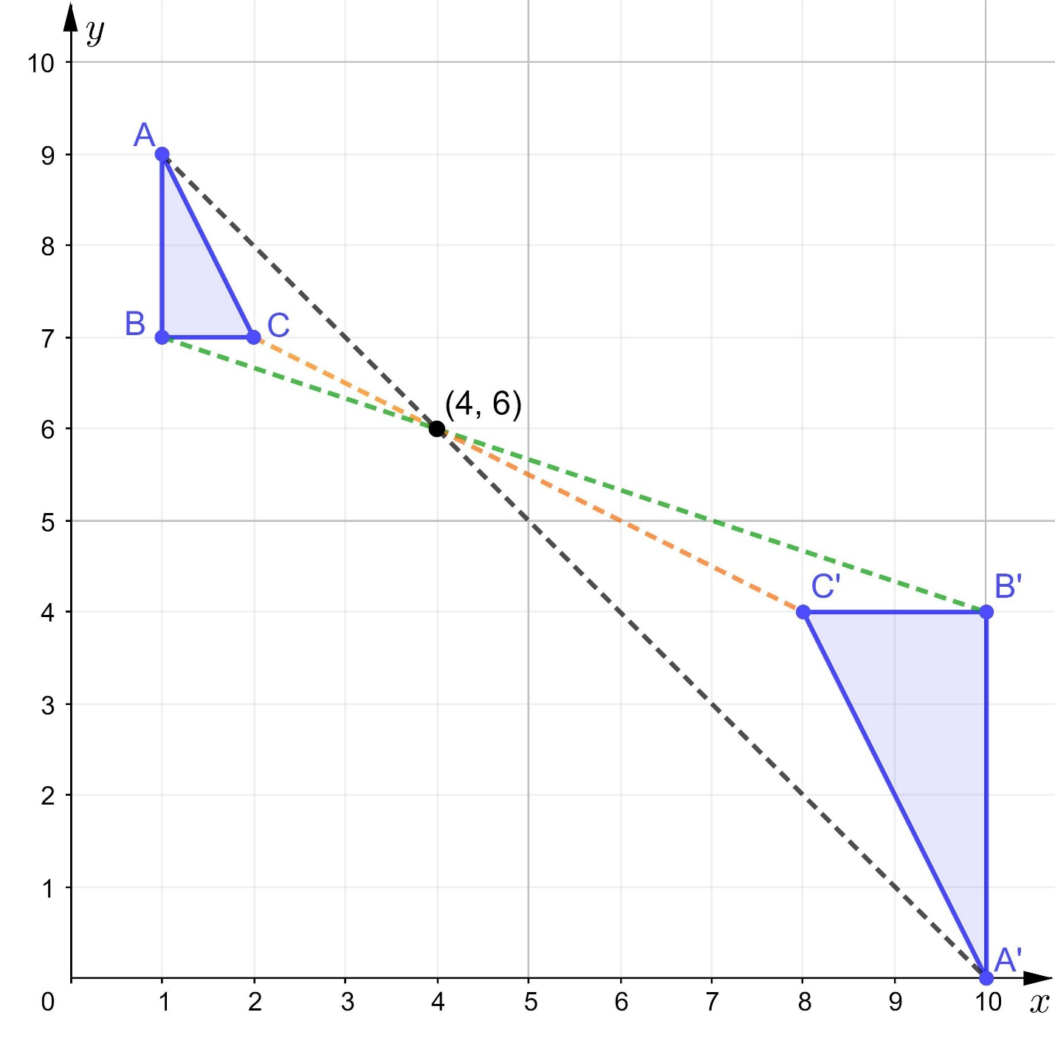
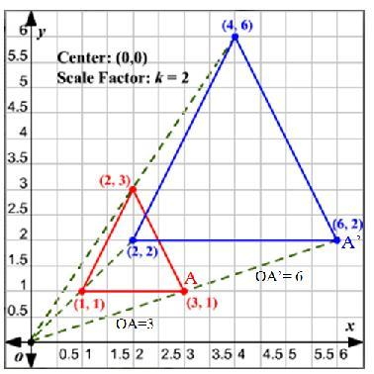
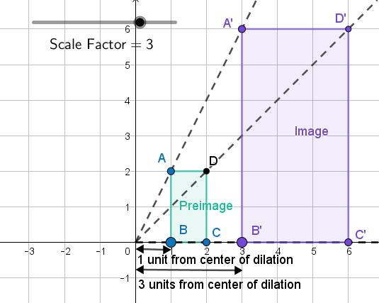

Purpose
# Source: AI Source: Provided by: [Data Path: Persons Table -> ID Column: 1, Name_En Column: Motasem Essam] -> From: [ChatGPT] on [7/25/2026]
Dilation is used to:
- Enlarge geometric figures.
- Reduce geometric figures.
- Study similarity.
- Change the scale of objects.
- Transform coordinates.
- Create maps and scale drawings.
- Model zooming in computer graphics.
- Support architectural and engineering designs.
- Analyze proportional relationships.

Fundamental Idea
# Source: AI Source: Provided by: [Data Path: Persons Table -> ID Column: 1, Name_En Column: Motasem Essam] -> From: [ChatGPT] on [7/25/2026]
A dilation changes the distance of every point from the center of dilation by the same scale factor.
If the scale factor is:
$$\boxed{k}$$
then:
$$\boxed{OA^{'}=k⋅OA}$$
where:
- $O$ = center of dilation
- $A$ = original point
- $A^{'}$ = image of the point
- $k$ = scale factor
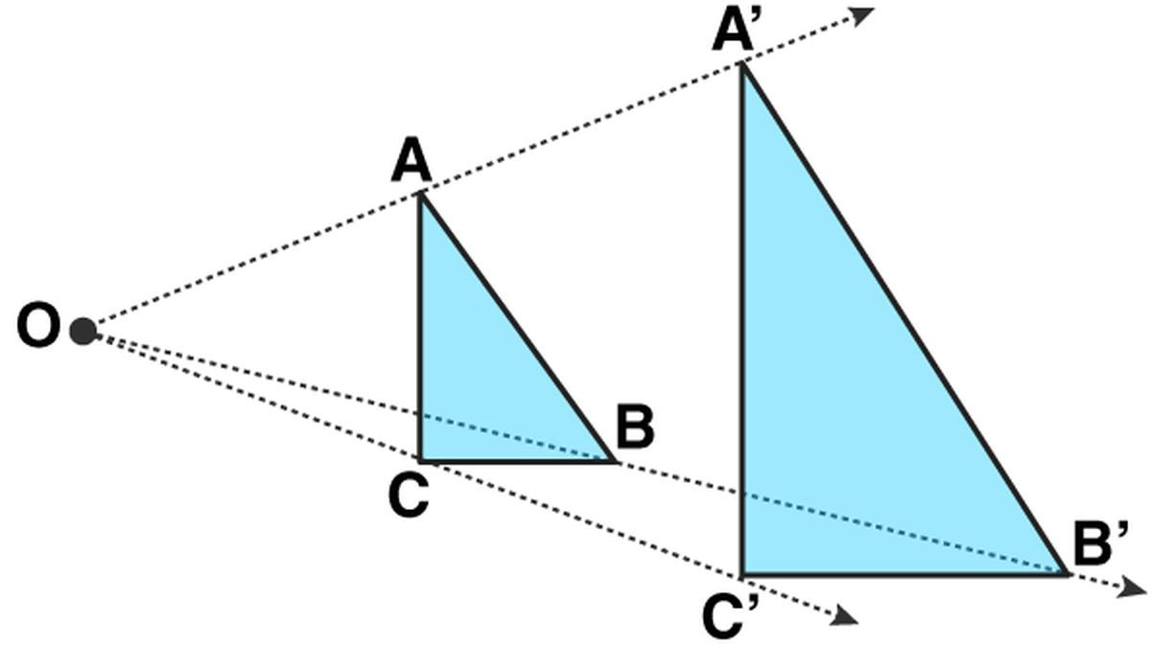
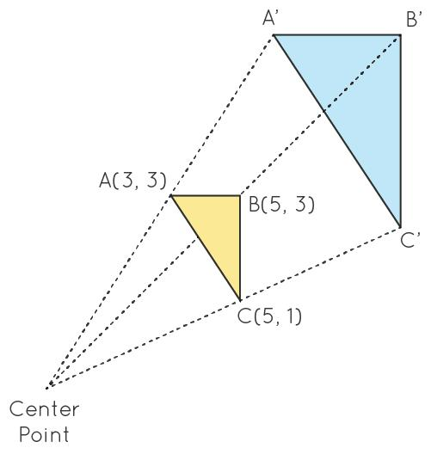

Center of Dilation
# Source: AI Source: Provided by: [Data Path: Persons Table -> ID Column: 1, Name_En Column: Motasem Essam] -> From: [ChatGPT] on [7/25/2026]
The center of dilation is the fixed point from which the figure is enlarged or reduced.
It is commonly represented by:
$$\boxed{O}$$
The original point, its image, and the center of dilation lie on the same line.
Therefore:
$$\boxed{O,A,A^{'}\text{ are collinear}}$$
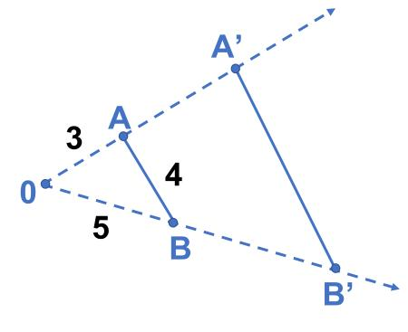
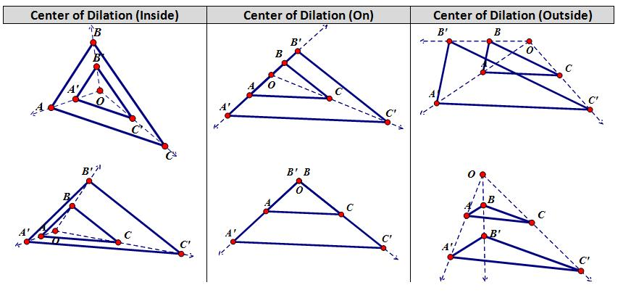
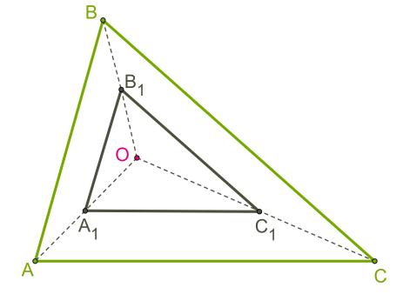

Scale Factor
# Source: AI Source: Provided by: [Data Path: Persons Table -> ID Column: 1, Name_En Column: Motasem Essam] -> From: [ChatGPT] on [7/25/2026]
The scale factor determines how much the figure changes in size.
It is represented by:
$$\boxed{k}$$
The scale factor is:
$$\boxed{k=\frac{\text{image length}}{\text{original length}}}$$
For example, if an original side is $4$units and the corresponding image side is $12$units:
$$k=\frac{12}{4} \\ \boxed{k=3}$$

Enlargement
# Source: AI Source: Provided by: [Data Path: Persons Table -> ID Column: 1, Name_En Column: Motasem Essam] -> From: [ChatGPT] on [7/25/2026]
When:
$$\boxed{k>1}$$
the figure becomes larger.
For example:
$$k=3$$
means every distance from the center becomes three times as large.
$$\boxed{OA^{'}=3OA}$$
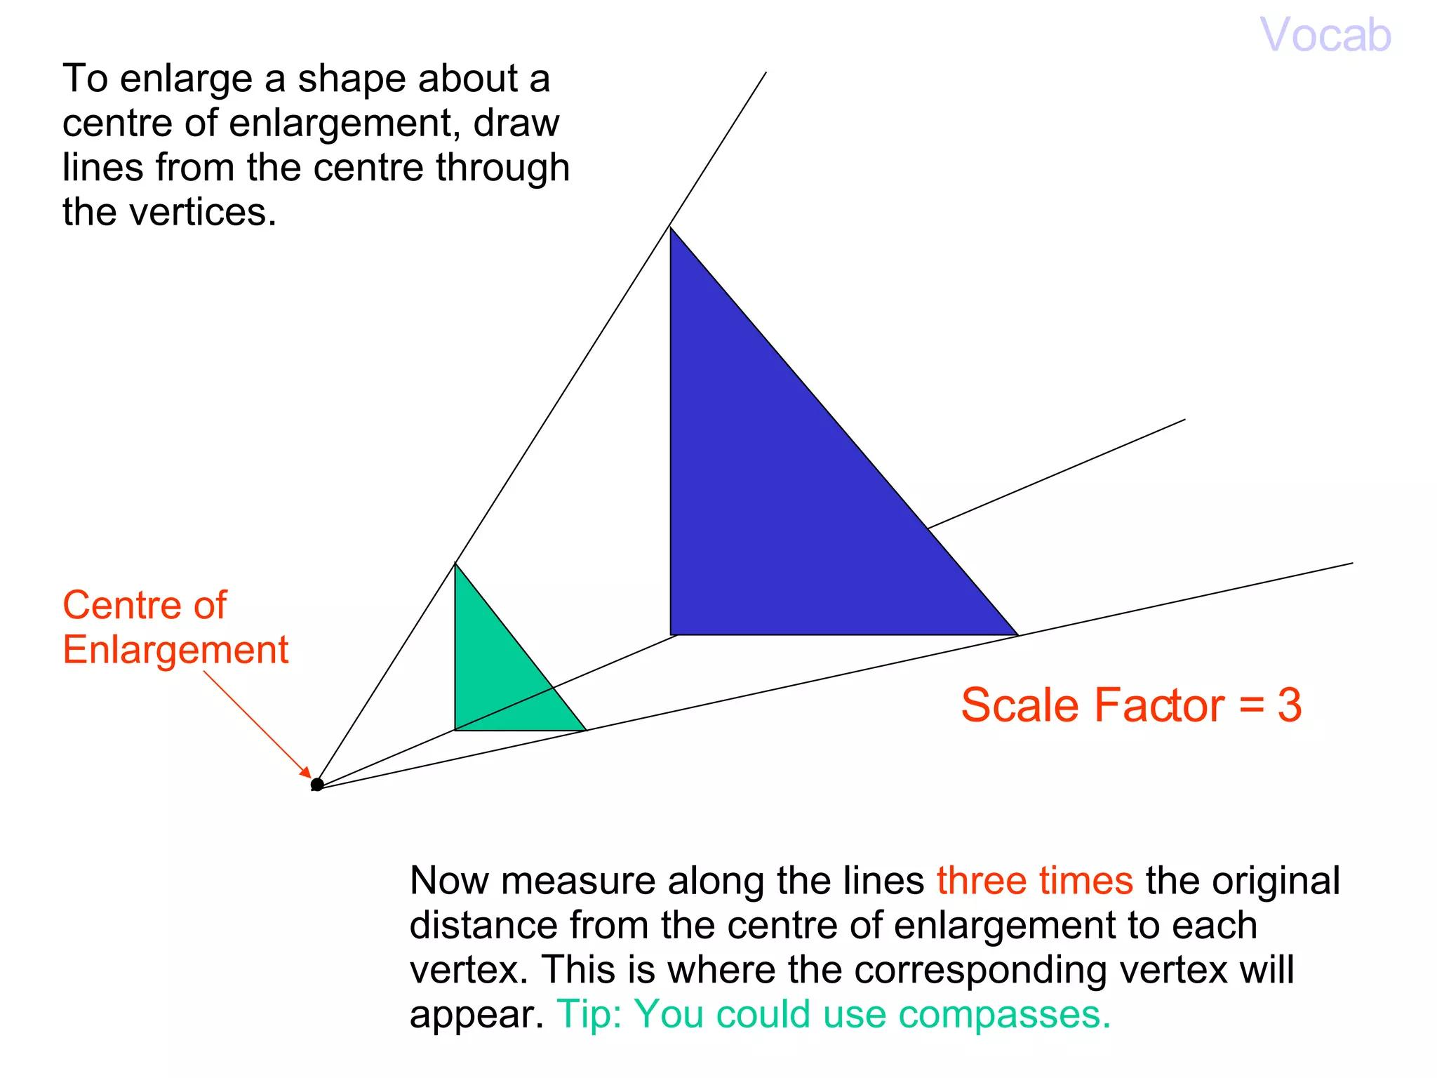
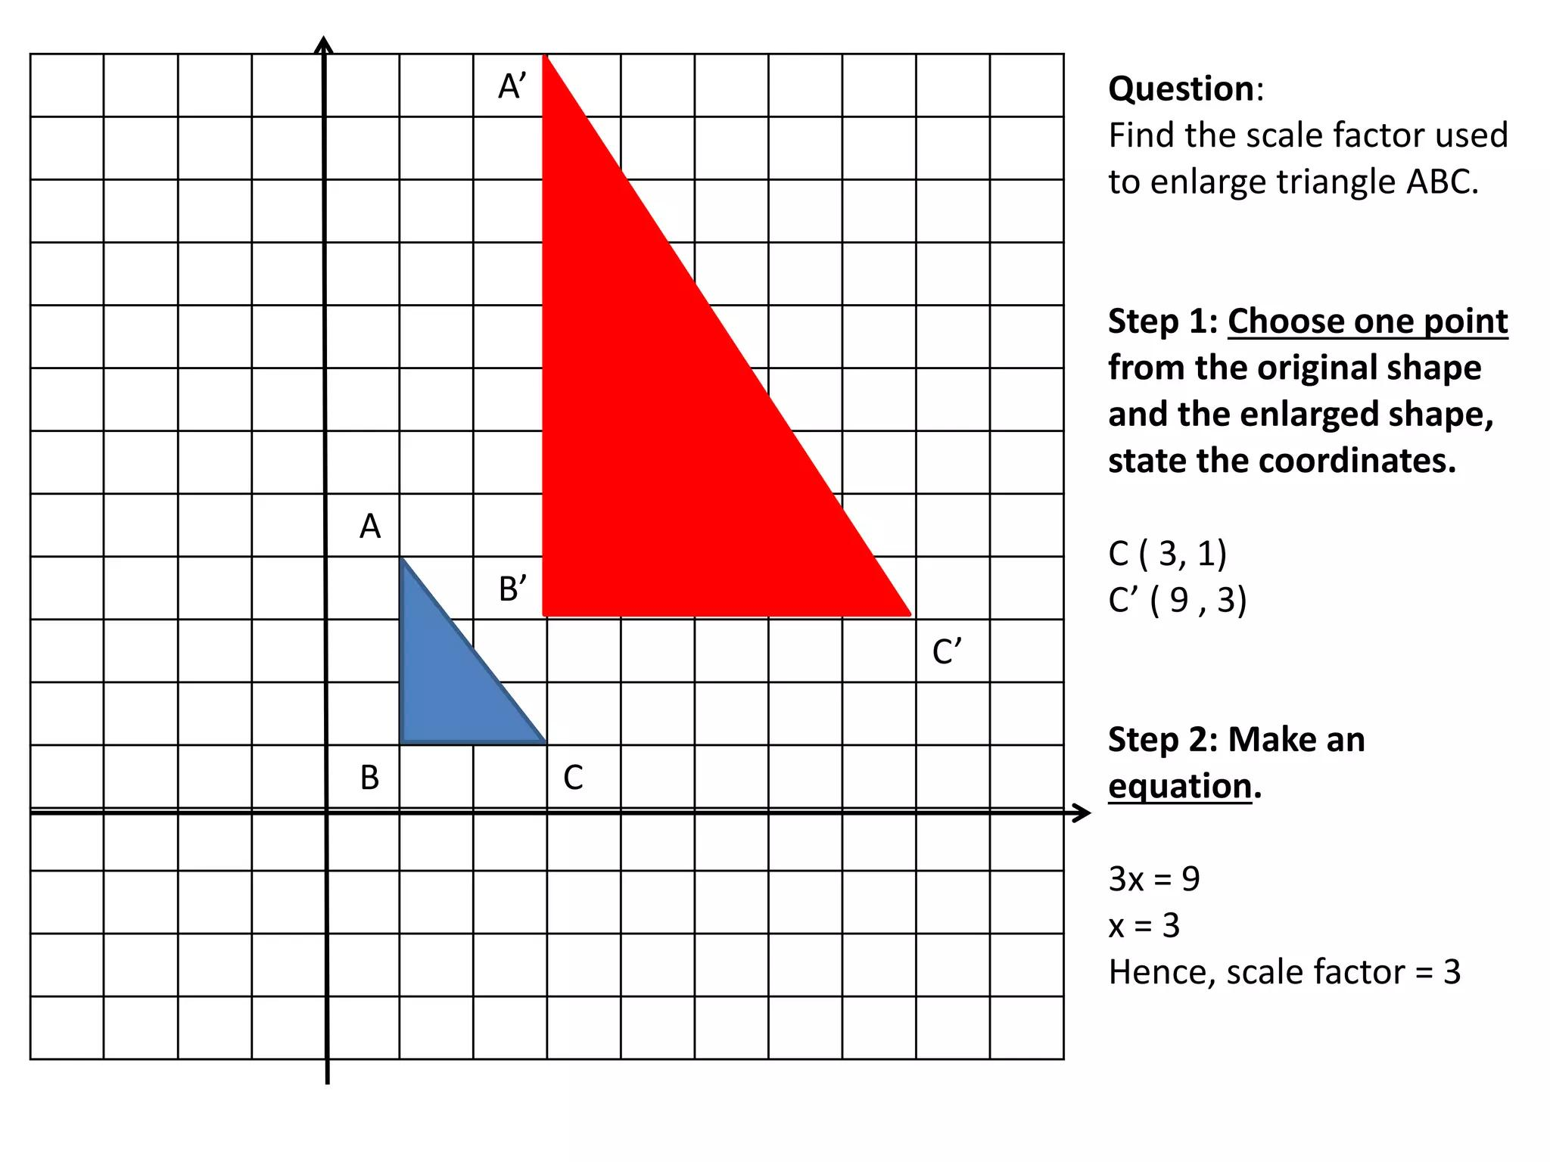
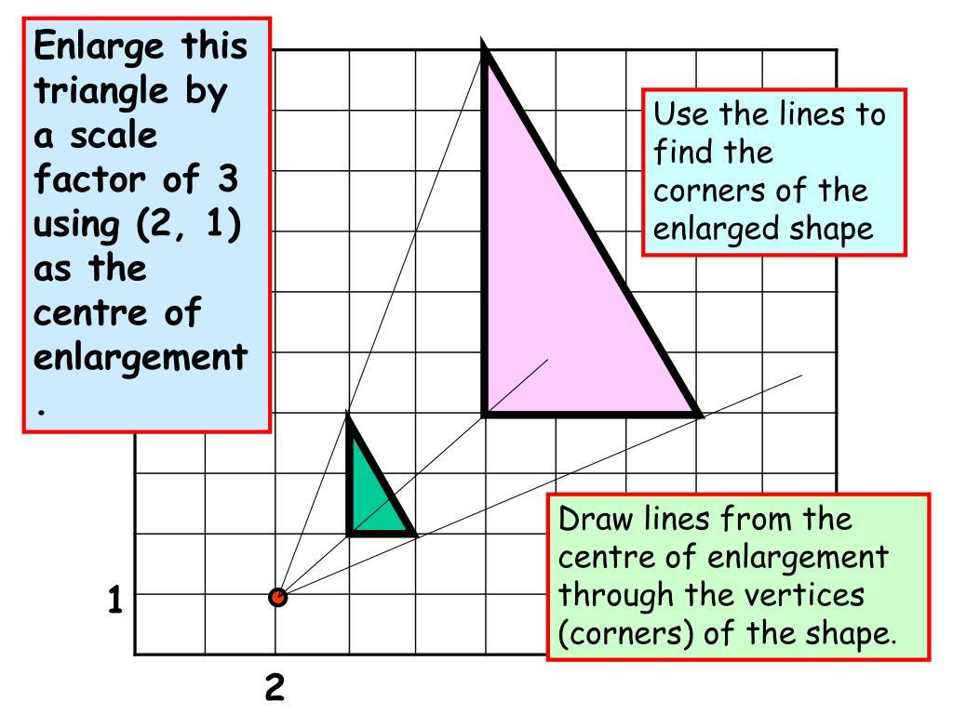
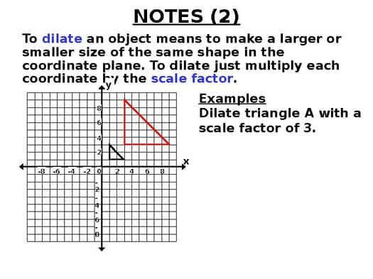
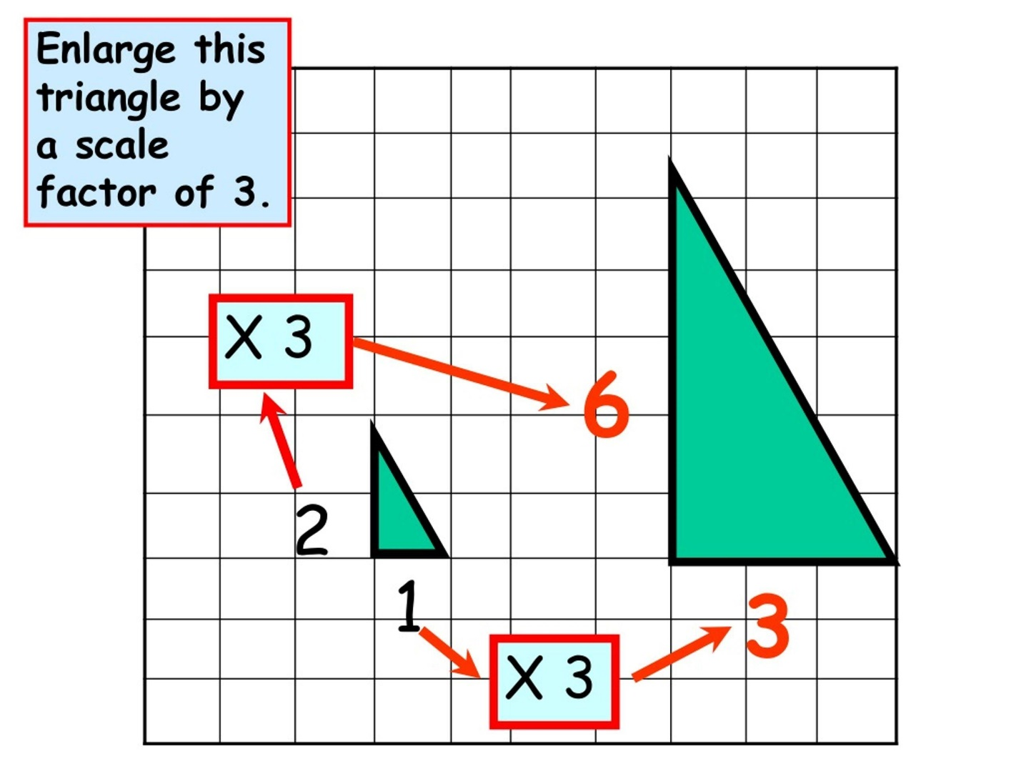

Reduction
# Source: AI Source: Provided by: [Data Path: Persons Table -> ID Column: 1, Name_En Column: Motasem Essam] -> From: [ChatGPT] on [7/25/2026]
When:
$$\boxed{0<k<1}$$
the figure becomes smaller.
For example:
$$k=\frac{1}{2}$$
means every distance from the center becomes half as large.
$$\boxed{OA^{'}=\frac{1}{2}OA}$$
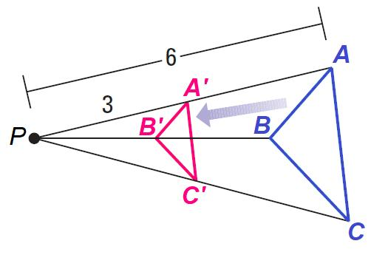
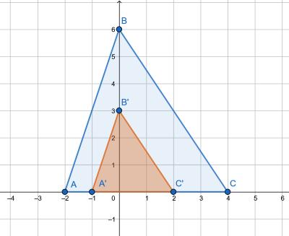
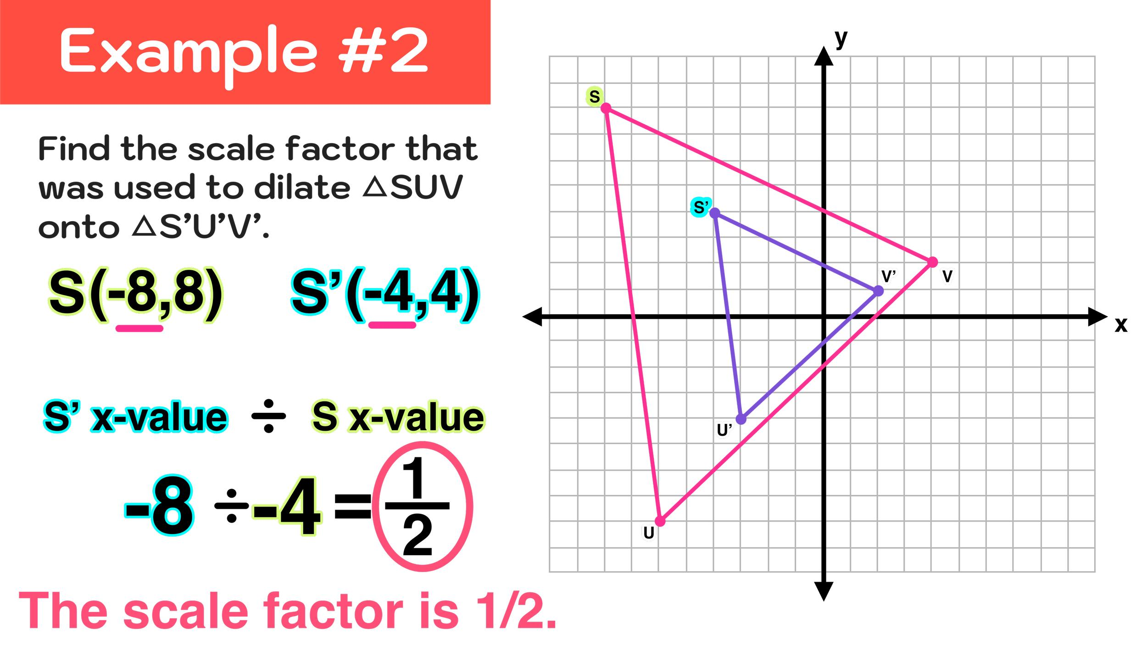
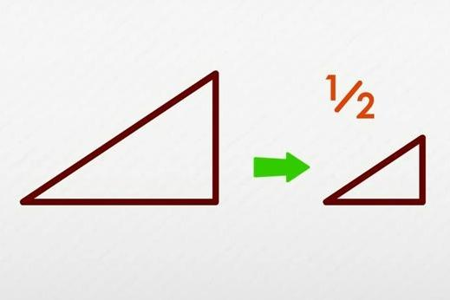
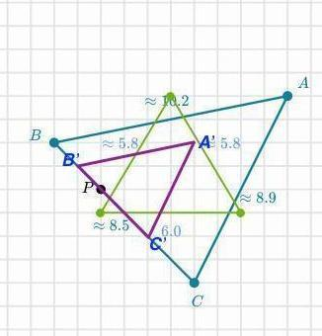

Scale Factor Equal to 1
# Source: AI Source: Provided by: [Data Path: Persons Table -> ID Column: 1, Name_En Column: Motasem Essam] -> From: [ChatGPT] on [7/25/2026]
When:
$$\boxed{k=1}$$
the figure does not change size.
$$\boxed{A^{'}=A}$$
Therefore, the transformation is effectively the identity transformation.

Negative Scale Factor
# Source: AI Source: Provided by: [Data Path: Persons Table -> ID Column: 1, Name_En Column: Motasem Essam] -> From: [ChatGPT] on [7/25/2026]
A negative scale factor changes the direction of the image relative to the center.
When:
$$\boxed{k<0}$$
the image lies on the opposite side of the center of dilation.
For example:
$$k=-2$$
means:
- The distance from the center is doubled.
- The image appears on the opposite side of the center.
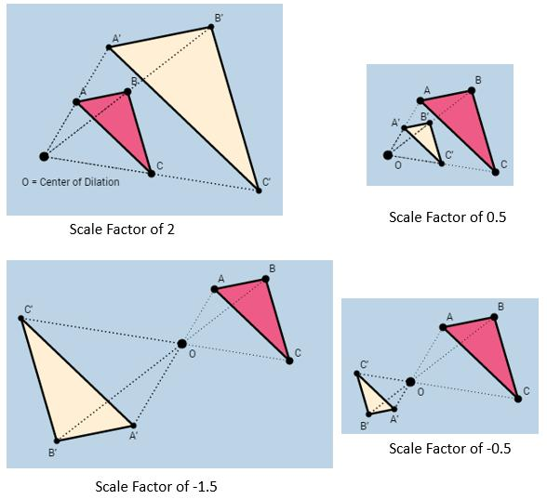
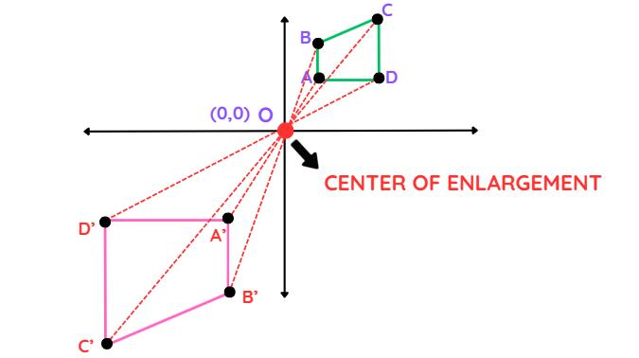
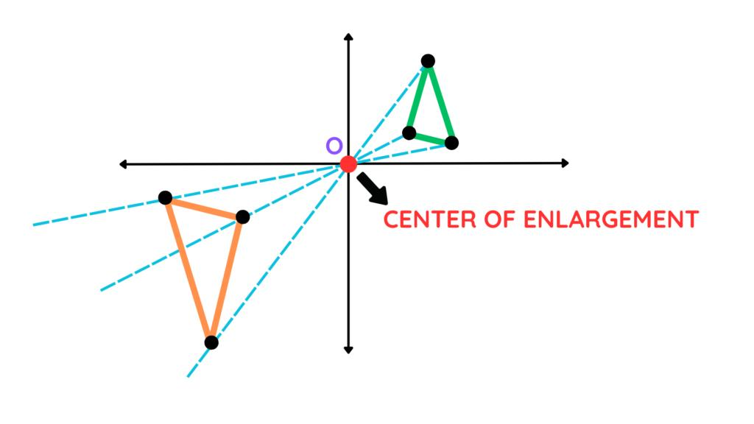
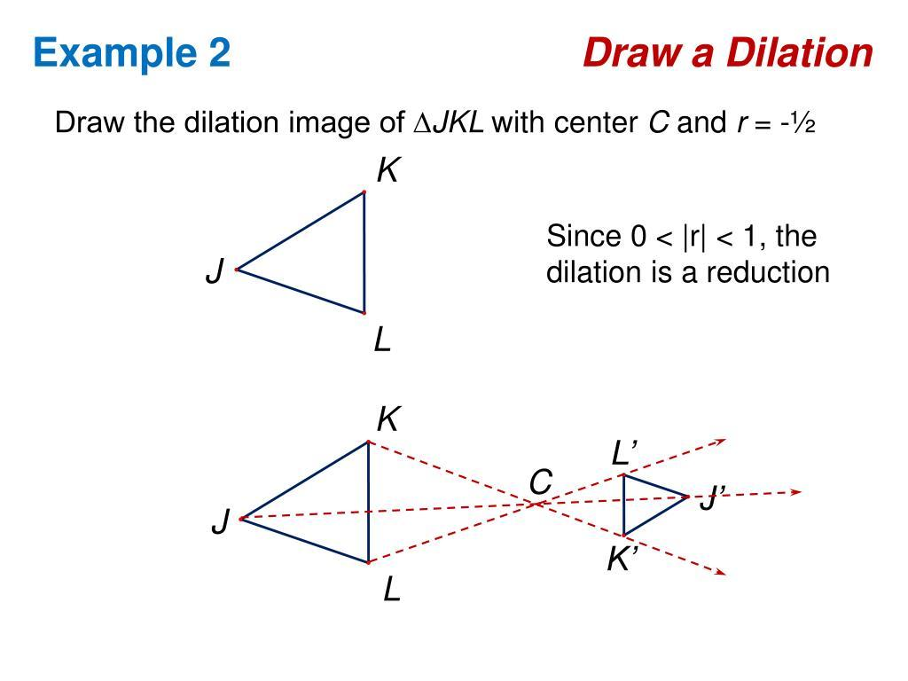
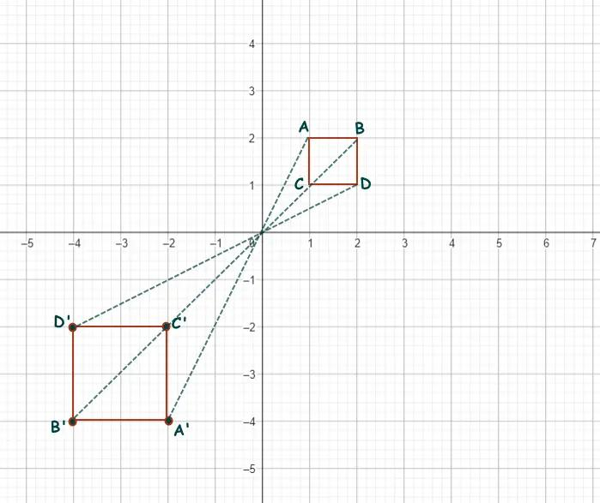

Dilation About the Origin
# Source: AI Source: Provided by: [Data Path: Persons Table -> ID Column: 1, Name_En Column: Motasem Essam] -> From: [ChatGPT] on [7/25/2026]
When the center of dilation is the origin:
$$\boxed{O=\left(0 , 0\right)}$$
the coordinate rule is:
$$\boxed{\left(x , y\right)→\left(kx , ky\right)}$$
This is the simplest coordinate rule for dilation.

Example — Enlargement
# Source: AI Source: Provided by: [Data Path: Persons Table -> ID Column: 1, Name_En Column: Motasem Essam] -> From: [ChatGPT] on [7/25/2026]
Suppose:
$$A=\left(2 , 3\right)$$
and:
$$k=2$$
Using:
$$\left(x , y\right)→\left(kx , ky\right)$$
we get:
$$A^{'}=\left(2\left(2\right) , 2\left(3\right)\right) \\ \boxed{A^{'}=\left(4 , 6\right)}$$
The point is twice as far from the origin.

Example — Reduction
# Source: AI Source: Provided by: [Data Path: Persons Table -> ID Column: 1, Name_En Column: Motasem Essam] -> From: [ChatGPT] on [7/25/2026]
Suppose:
$$B=\left(6 , 4\right)$$
and:
$$k=\frac{1}{2}$$
Then:
$$B^{'}=\left(\frac{1}{2}\left(6\right) , \frac{1}{2}\left(4\right)\right)$$
Therefore:
$$\boxed{B^{'}=\left(3 , 2\right)}$$

Dilation of a Triangle
# Source: AI Source: Provided by: [Data Path: Persons Table -> ID Column: 1, Name_En Column: Motasem Essam] -> From: [ChatGPT] on [7/25/2026]
Suppose a triangle has vertices:
$$A=\left(1 , 1\right) \\ B=\left(4 , 1\right) \\ C=\left(2 , 3\right)$$
Dilate the triangle about the origin with:
$$k=2$$
Then:
$$A^{'}=\left(2 , 2\right) \\ B^{'}=\left(8 , 2\right) \\ C^{'}=\left(4 , 6\right)$$
Therefore:
$$\boxed{A^{'}\left(2 , 2\right), B^{'}\left(8 , 2\right), C^{'}\left(4 , 6\right)}$$
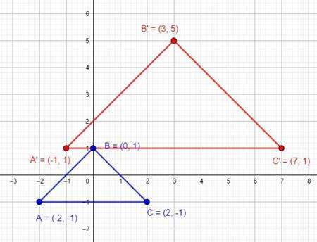
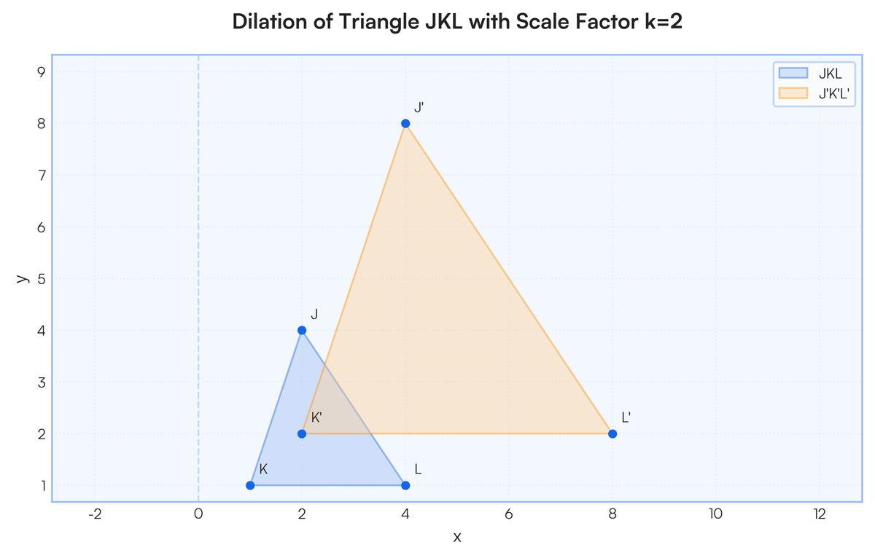
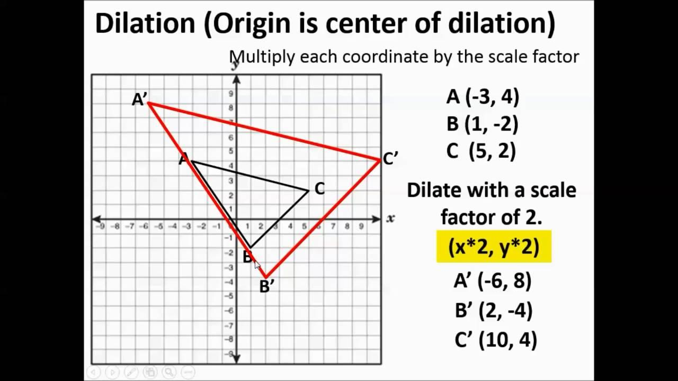
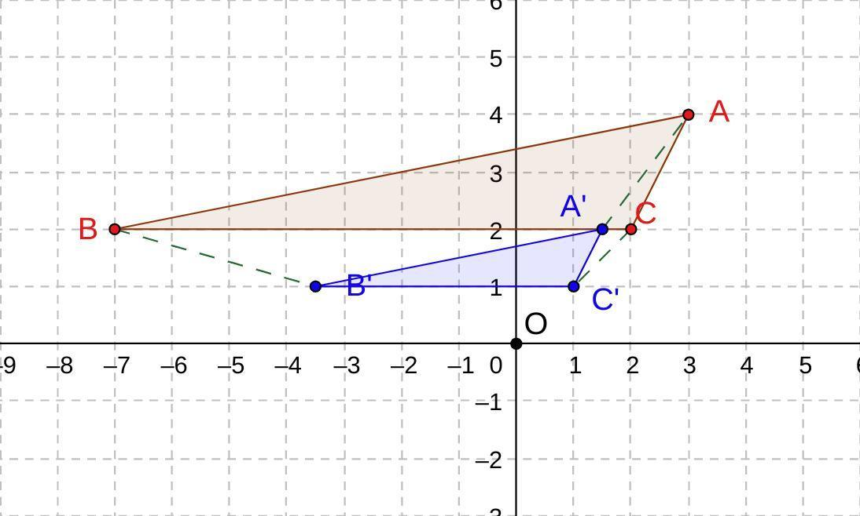

Dilation Preserves Shape
# Source: AI Source: Provided by: [Data Path: Persons Table -> ID Column: 1, Name_En Column: Motasem Essam] -> From: [ChatGPT] on [7/25/2026]
Dilation preserves the shape of a figure.
For example, a triangle remains a triangle, and a square remains a square.
$$\boxed{{\text{Shape}}_{original}={\text{Shape}}_{image}}$$
The corresponding angles remain equal.

Dilation Preserves Angles
# Source: AI Source: Provided by: [Data Path: Persons Table -> ID Column: 1, Name_En Column: Motasem Essam] -> From: [ChatGPT] on [7/25/2026]
Dilation preserves angle measures.
If:
$$∠A={60}^{∘}$$
then:
$$\boxed{∠A^{'}={60}^{∘}}$$
Therefore:
$$\boxed{∠A=∠A^{'}}$$

Dilation Preserves Proportions
# Source: AI Source: Provided by: [Data Path: Persons Table -> ID Column: 1, Name_En Column: Motasem Essam] -> From: [ChatGPT] on [7/25/2026]
Corresponding lengths are multiplied by the same scale factor.
If:
$$AB=4$$
and:
$$A^{'}B^{'}=12$$
then:
$$\frac{A^{'}B^{'}}{AB}=\frac{12}{4}=3$$
Therefore:
$$\boxed{k=3}$$
All corresponding sides have the same ratio.

Dilation Changes Side Lengths
# Source: AI Source: Provided by: [Data Path: Persons Table -> ID Column: 1, Name_En Column: Motasem Essam] -> From: [ChatGPT] on [7/25/2026]
Unlike rigid transformations, dilation changes lengths when:
$$k≠1$$
The new length is:
$$\boxed{L^{'}=kL}$$
For example:
$$L=5$$
and:
$$k=2$$
then:
$$\boxed{L^{'}=10}$$

Dilation Changes Perimeter
# Source: AI Source: Provided by: [Data Path: Persons Table -> ID Column: 1, Name_En Column: Motasem Essam] -> From: [ChatGPT] on [7/25/2026]
The perimeter is multiplied by the absolute value of the scale factor.
$$\boxed{P^{'}=∣k∣P}$$
For example, if:
$$P=20$$
and:
$$k=3$$
then:
$$\boxed{P^{'}=60}$$

Dilation Changes Area
# Source: AI Source: Provided by: [Data Path: Persons Table -> ID Column: 1, Name_En Column: Motasem Essam] -> From: [ChatGPT] on [7/25/2026]
The area is multiplied by the square of the scale factor.
$$\boxed{A^{'}=k^{2}A}$$
For example, if:
$$A=10$$
and:
$$k=3$$
then:
$$A^{'}=3^{2}\left(10\right) \\ \boxed{A^{'}=90}$$
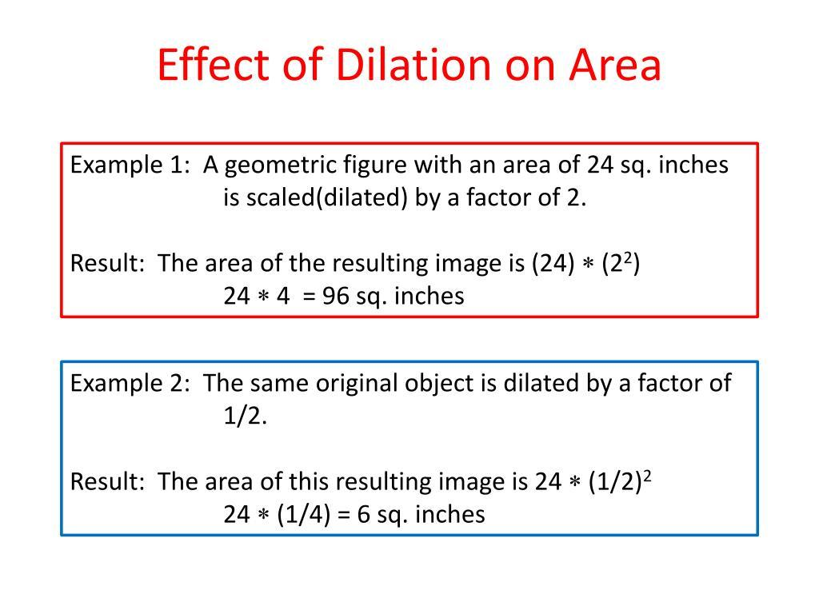
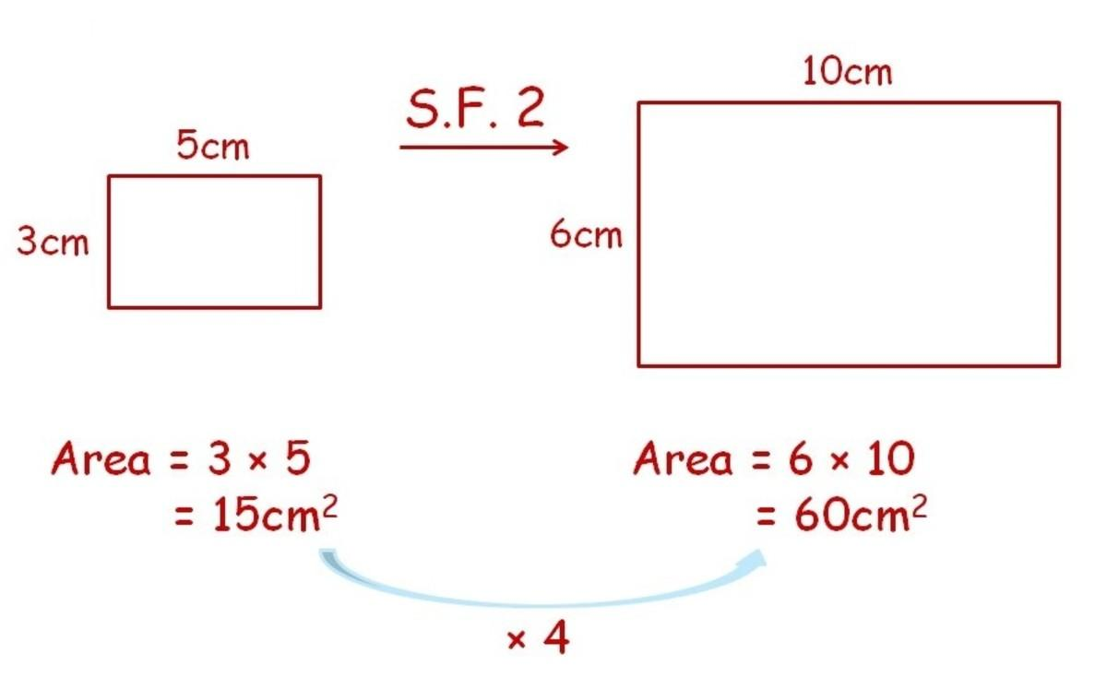
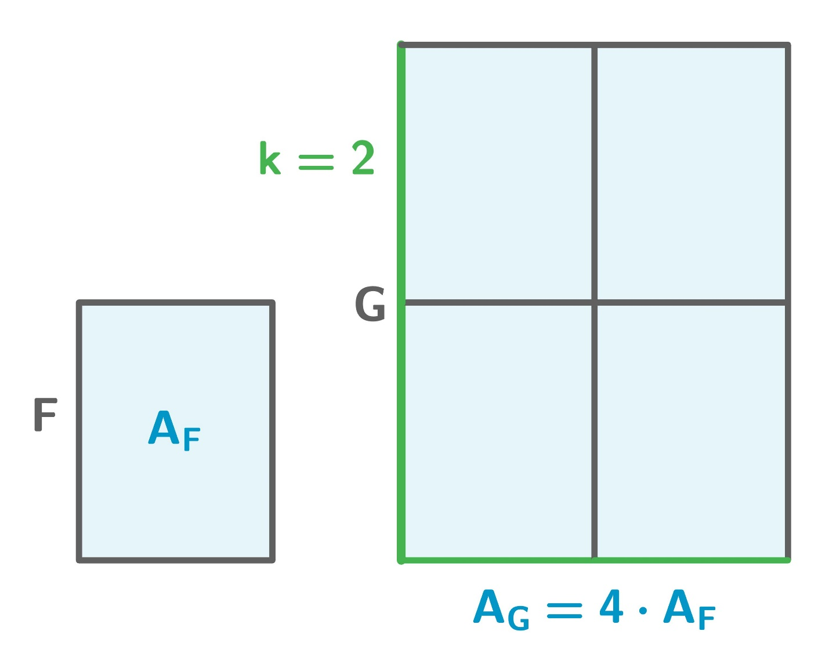
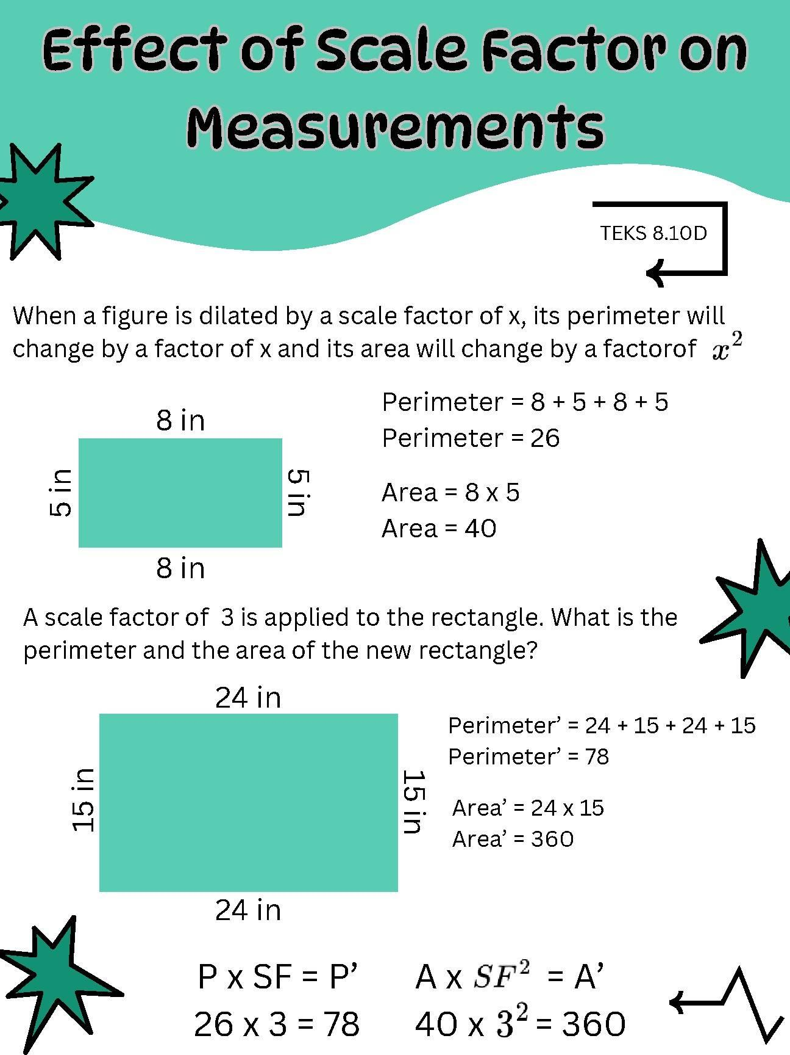

Dilation and Similarity
# Source: AI Source: Provided by: [Data Path: Persons Table -> ID Column: 1, Name_En Column: Motasem Essam] -> From: [ChatGPT] on [7/25/2026]
Dilation is one of the fundamental transformations used to create similar figures.
Two figures are similar when:
- Corresponding angles are equal.
- Corresponding sides are proportional.
Therefore:
$$\boxed{F∼F^{'}}$$
A dilation produces a figure that is similar to the original.

Dilation and Congruence
# Source: AI Source: Provided by: [Data Path: Persons Table -> ID Column: 1, Name_En Column: Motasem Essam] -> From: [ChatGPT] on [7/25/2026]
If:
$$k=1$$
the figure remains the same size and is congruent to itself.
If:
$$k≠1$$
the figure changes size, so the original and image are generally similar but not congruent.
Therefore:
$$\boxed{k≠1⇒F∼F^{'}}$$
but generally:
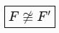
$$\boxed{F≇F^{'}}$$

Dilation of a Circle
# Source: AI Source: Provided by: [Data Path: Persons Table -> ID Column: 1, Name_En Column: Motasem Essam] -> From: [ChatGPT] on [7/25/2026]
A circle remains a circle after dilation.
If the original radius is:
$$r$$
then the new radius is:
$$\boxed{r^{'}=∣k∣r}$$
For example:
$$r=4$$
and:
$$k=3$$
then:
$$\boxed{r^{'}=12}$$
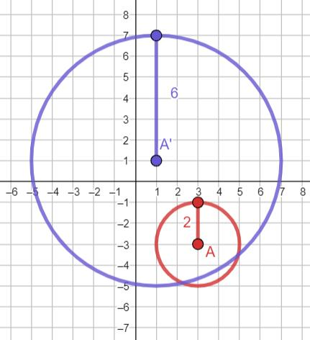
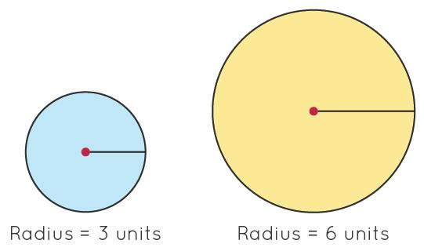
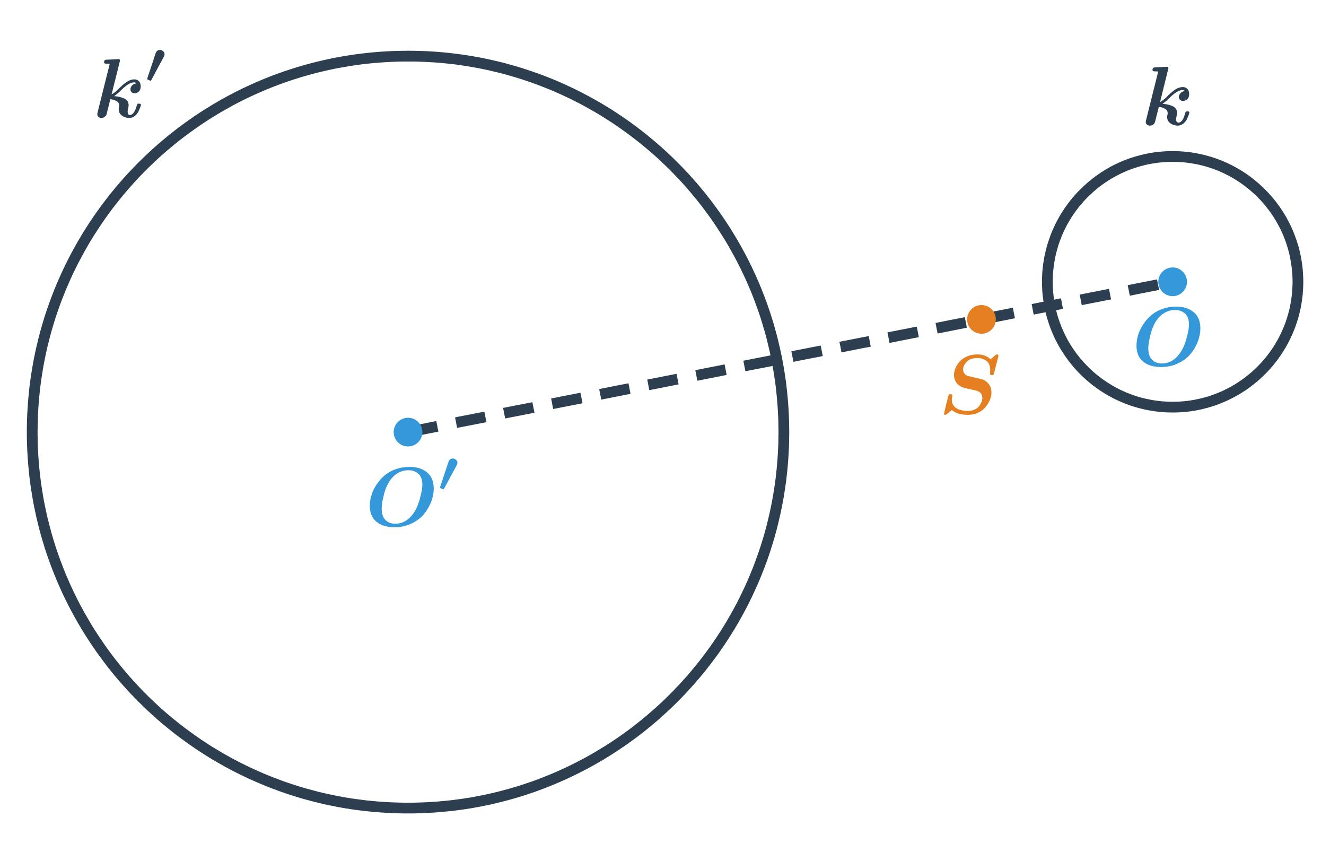
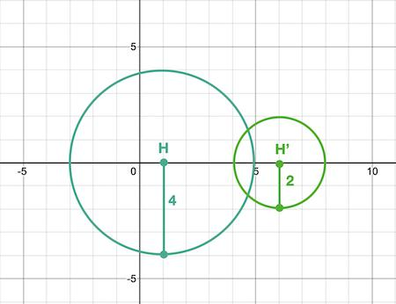

Dilation of a Line Segment
# Source: AI Source: Provided by: [Data Path: Persons Table -> ID Column: 1, Name_En Column: Motasem Essam] -> From: [ChatGPT] on [7/25/2026]
Suppose:
$$AB=6$$
and:
$$k=2$$
Then:
$$A^{'}B^{'}=2\left(6\right) \\ \boxed{A^{'}B^{'}=12}$$
The segment remains straight, but its length changes.

Dilation of a Polygon
# Source: AI Source: Provided by: [Data Path: Persons Table -> ID Column: 1, Name_En Column: Motasem Essam] -> From: [ChatGPT] on [7/25/2026]
For a polygon, every vertex is moved relative to the center of dilation by the same scale factor.
If:
$$P=\left(x , y\right)$$
and the center is the origin, then:
$$\boxed{P^{'}=\left(kx , ky\right)}$$
Every side is multiplied by:
$$\boxed{∣k∣}$$
and the area is multiplied by:
$$\boxed{k^{2}}$$

Dilation About a Point Other Than the Origin
# Source: AI Source: Provided by: [Data Path: Persons Table -> ID Column: 1, Name_En Column: Motasem Essam] -> From: [ChatGPT] on [7/25/2026]
A dilation does not have to be centered at:
$$\left(0 , 0\right)$$
Suppose the center of dilation is:
$$O=\left(h , k\right)$$
Then the coordinate rule is:
$$\boxed{x^{'}=h+s\left(x-h\right)} \\ \boxed{y^{'}=k+s\left(y-k\right)}$$
where $s$is the scale factor.
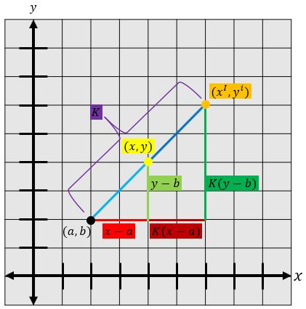
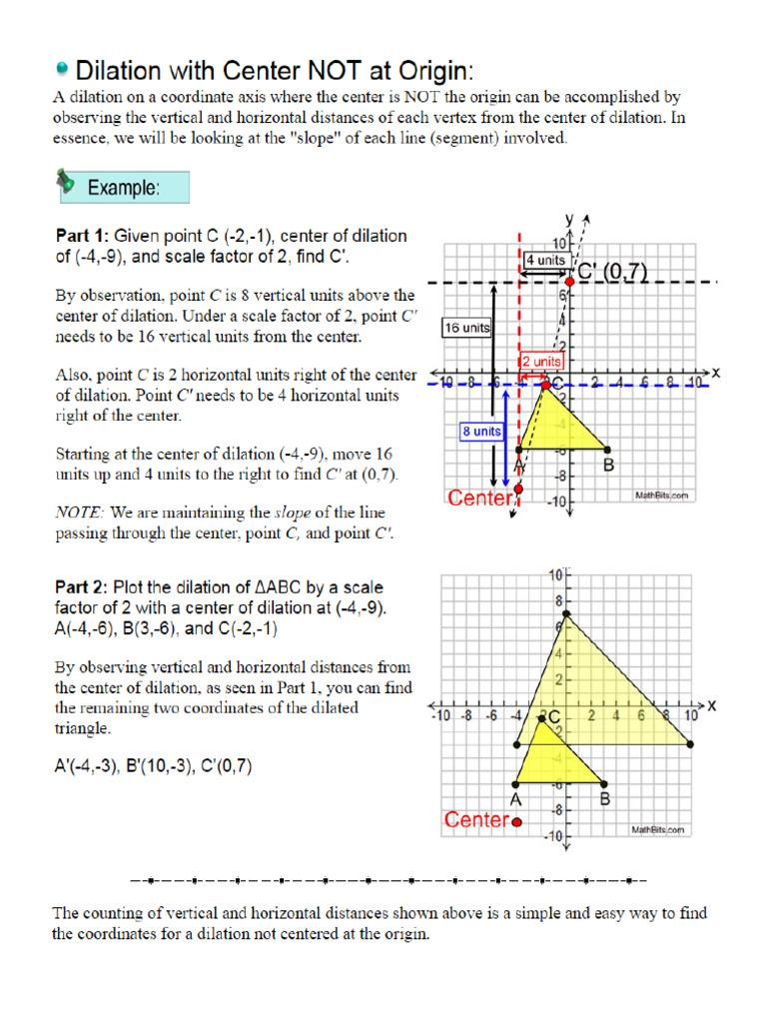
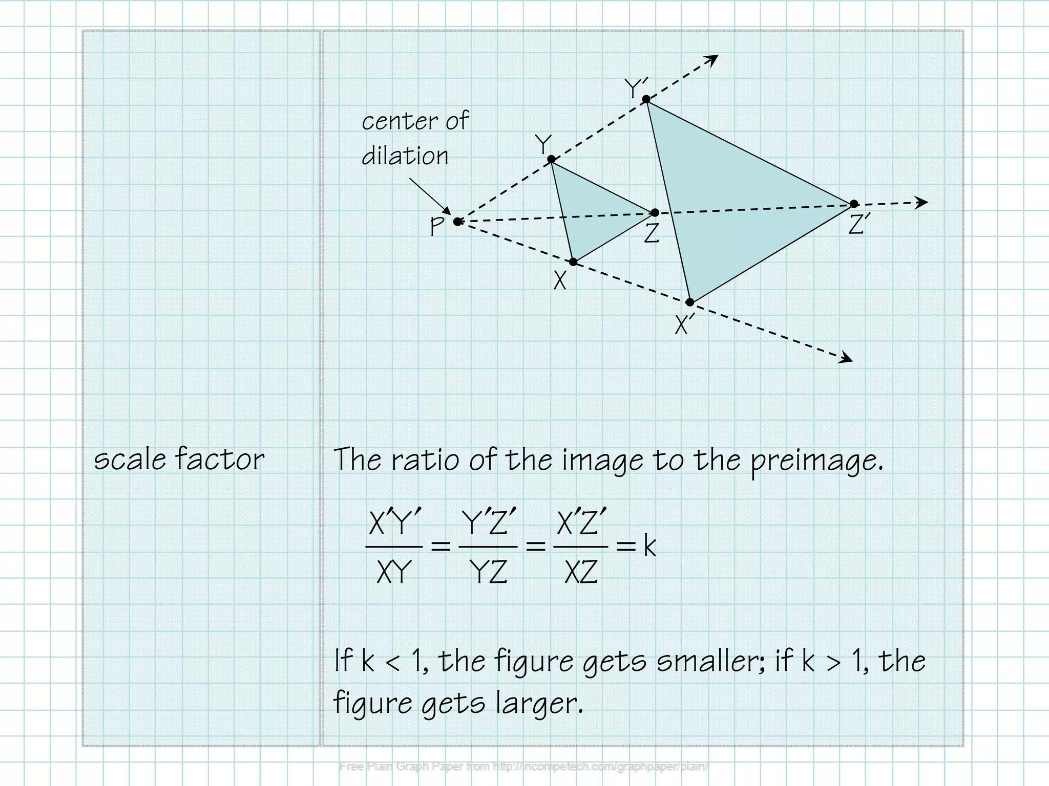
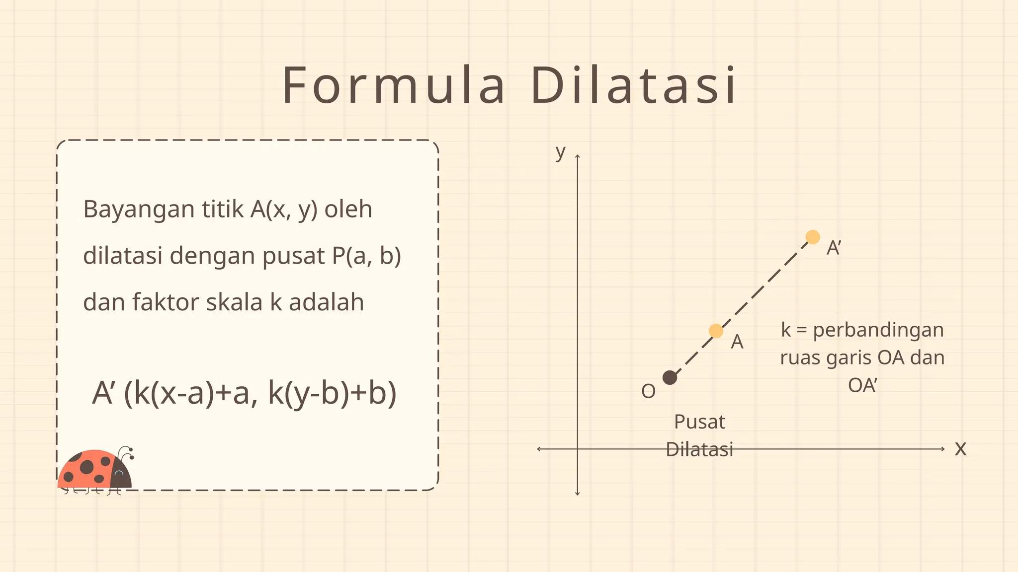

Example — Dilation About Another Center
# Source: AI Source: Provided by: [Data Path: Persons Table -> ID Column: 1, Name_En Column: Motasem Essam] -> From: [ChatGPT] on [7/25/2026]
Suppose:
$$O=\left(1 , 2\right)$$
and:
$$A=\left(3 , 4\right)$$
with scale factor:
$$k=2$$
Use:
$$x^{'}=h+k\left(x-h\right) \\ y^{'}=k_{0}+k\left(y-k_{0}\right)$$
To avoid confusing the center coordinate $k_{0}$with the scale factor, let the center be:
$$O=\left(h , c\right)$$
Then:
$$x^{'}=h+s\left(x-h\right) \\ y^{'}=c+s\left(y-c\right)$$
Here:
$$h=1, c=2, s=2$$
So:
$$x^{'}=1+2\left(3-1\right)=5 \\ y^{'}=2+2\left(4-2\right)=6$$
Therefore:
$$\boxed{A^{'}=\left(5 , 6\right)}$$

Collinearity Property
# Source: AI Source: Provided by: [Data Path: Persons Table -> ID Column: 1, Name_En Column: Motasem Essam] -> From: [ChatGPT] on [7/25/2026]
The center of dilation, an original point, and its image lie on the same straight line.
Therefore:
$$\boxed{O,A,A^{'}\text{ are collinear}}$$
This is one of the defining geometric properties of dilation.

Distance Relationship
# Source: AI Source: Provided by: [Data Path: Persons Table -> ID Column: 1, Name_En Column: Motasem Essam] -> From: [ChatGPT] on [7/25/2026]
For a dilation with scale factor $k$:
$$\boxed{OA^{'}=∣k∣OA}$$
For a positive scale factor:
$$k>0$$
the image remains in the same direction from the center.
For a negative scale factor:
$$k<0$$
the image lies in the opposite direction.

Composition of Dilations
# Source: AI Source: Provided by: [Data Path: Persons Table -> ID Column: 1, Name_En Column: Motasem Essam] -> From: [ChatGPT] on [7/25/2026]
Two dilations with the same center can be combined by multiplying their scale factors.
Suppose:
$$k_{1}=2$$
and:
$$k_{2}=3$$
Then:
$$k=2\left(3\right) \\ \boxed{k=6}$$
Therefore, the two dilations are equivalent to one dilation with scale factor $6$.

Dilation and Coordinate Geometry
# Source: AI Source: Provided by: [Data Path: Persons Table -> ID Column: 1, Name_En Column: Motasem Essam] -> From: [ChatGPT] on [7/25/2026]
Dilation is especially important in coordinate geometry because coordinates can be transformed directly.
For a dilation centered at the origin:
$$\boxed{\left(x , y\right)→\left(kx , ky\right)}$$
This allows geometric figures to be enlarged or reduced without constructing them manually.

Dilation in Maps
# Source: AI Source: Provided by: [Data Path: Persons Table -> ID Column: 1, Name_En Column: Motasem Essam] -> From: [ChatGPT] on [7/25/2026]
Maps use scale relationships to represent large geographic regions at smaller sizes.
For example:
$$1\text{ cm}=1\text{ km}$$
A map is effectively a scaled representation of a real-world region.
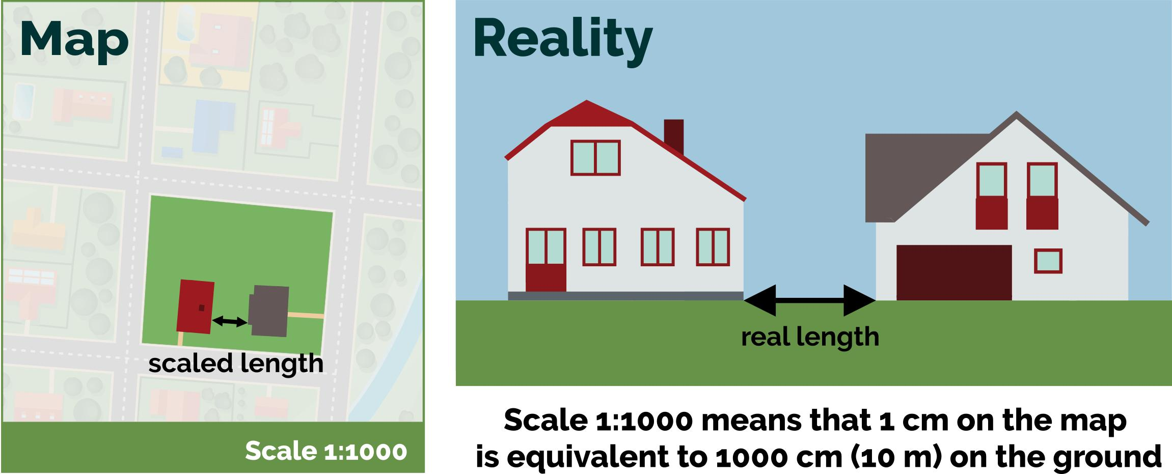
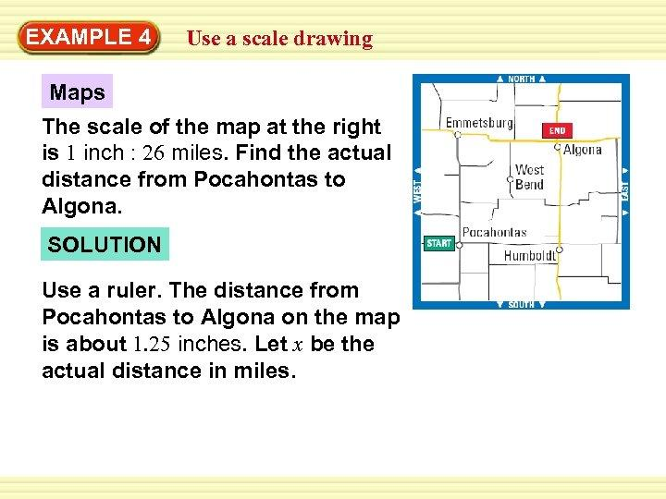
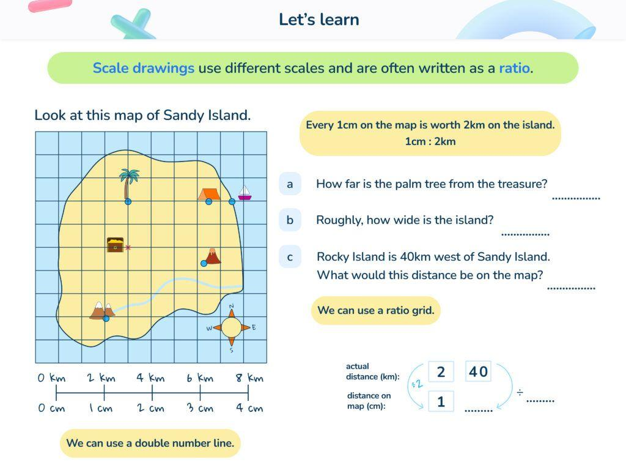
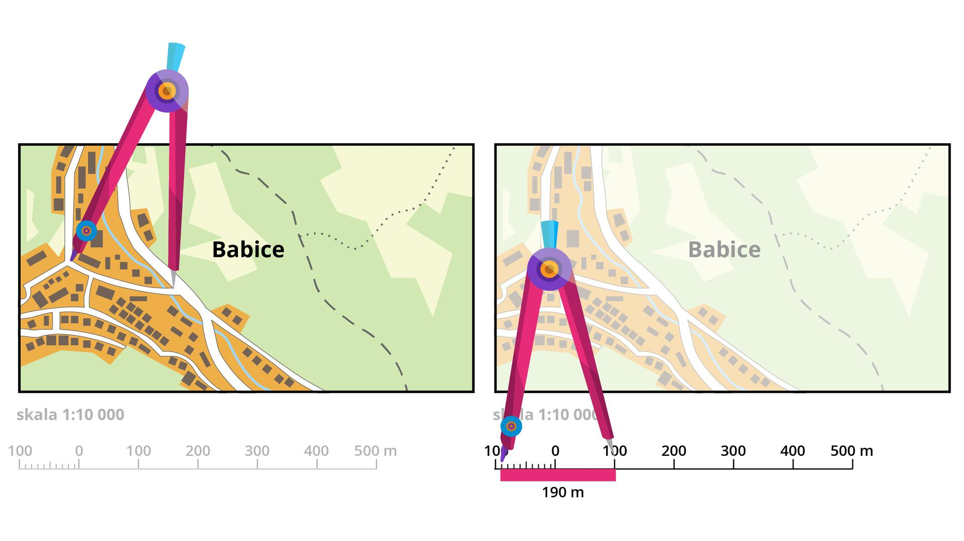

Dilation in Architecture
# Source: AI Source: Provided by: [Data Path: Persons Table -> ID Column: 1, Name_En Column: Motasem Essam] -> From: [ChatGPT] on [7/25/2026]
Architectural drawings often use scale factors.
For example:
$$1:100$$
means that:
$$1\text{ unit on the drawing}=100\text{ corresponding units in reality}$$
Scale drawings preserve proportions while changing size.
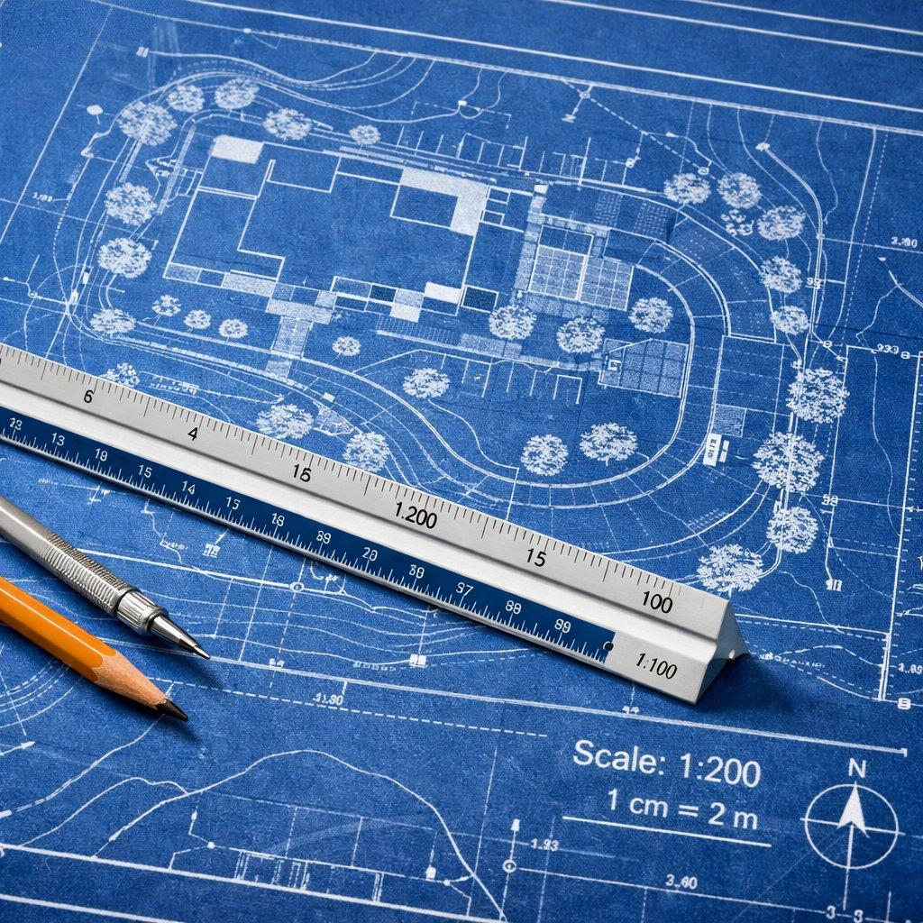
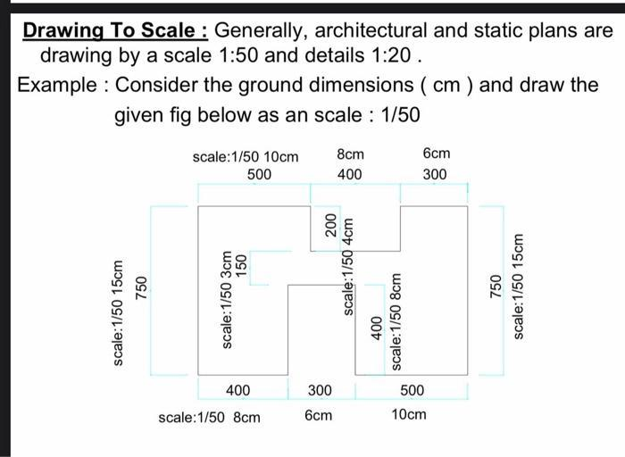
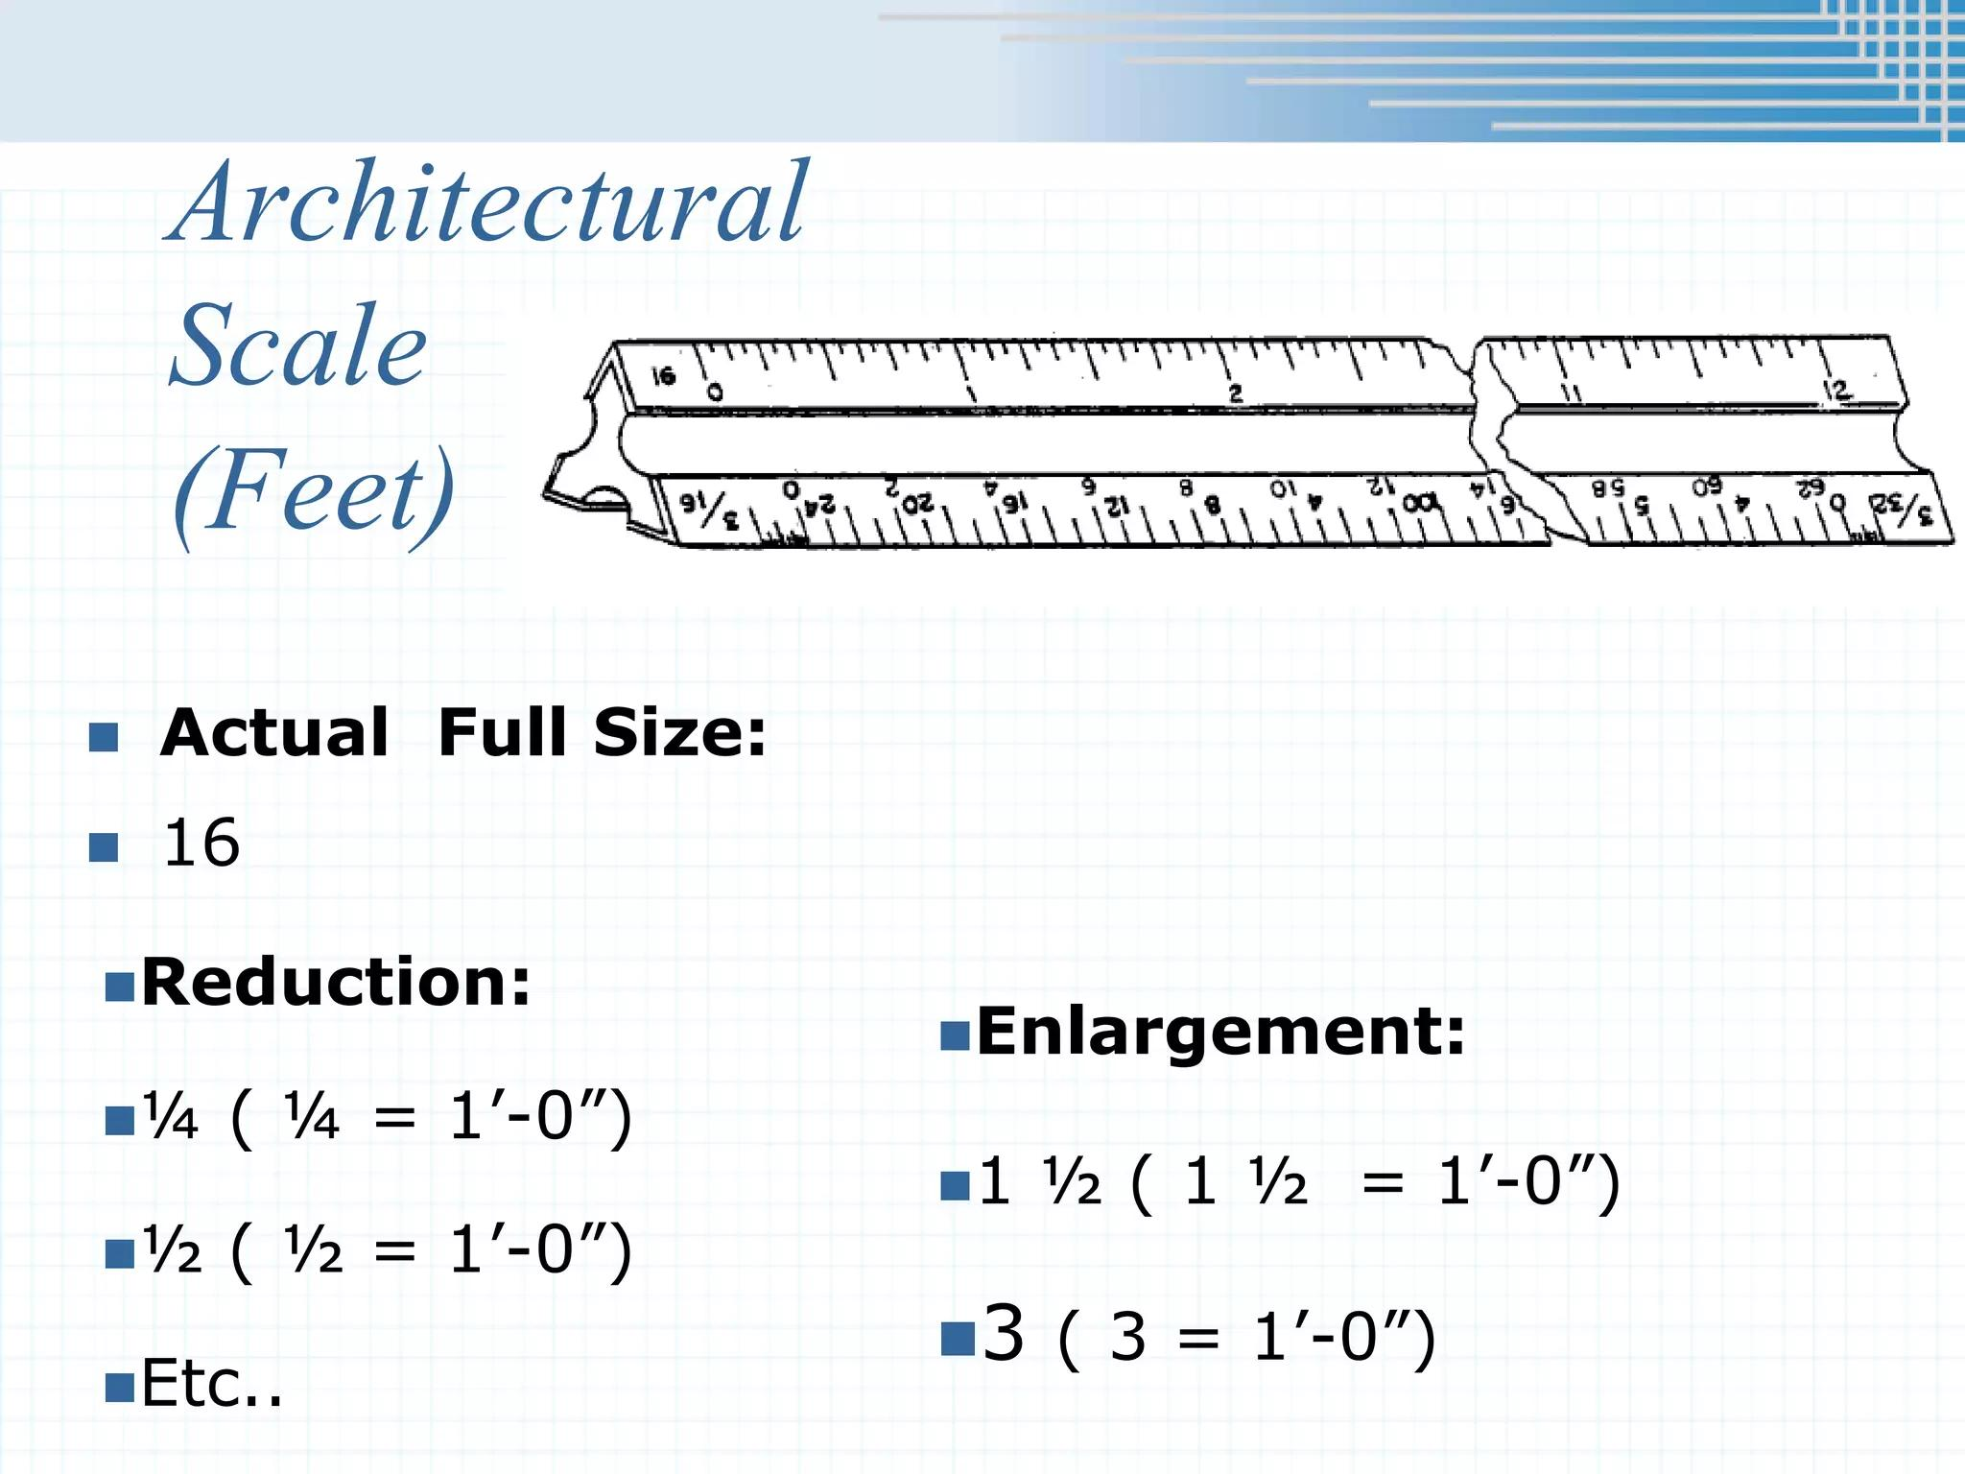
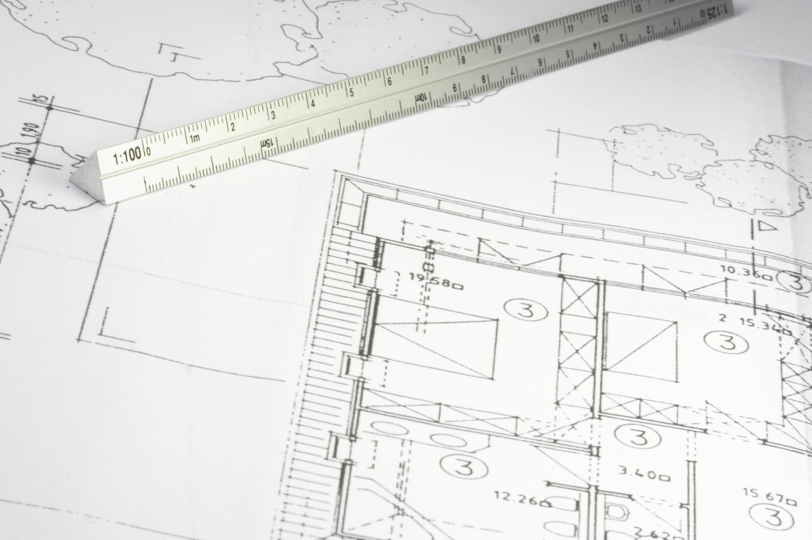
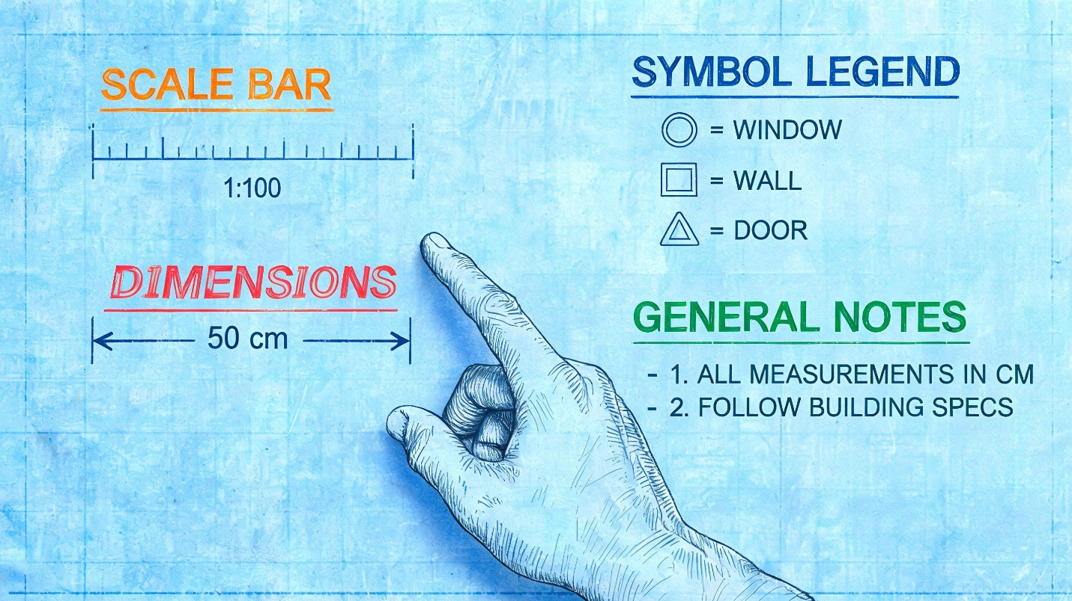

Dilation in Engineering
# Source: AI Source: Provided by: [Data Path: Persons Table -> ID Column: 1, Name_En Column: Motasem Essam] -> From: [ChatGPT] on [7/25/2026]
Engineers use scale models to represent large or complex objects.
Examples include:
- Bridges
- Buildings
- Aircraft
- Vehicles
- Machines
- Mechanical components
The model maintains the proportions of the original object.

Dilation in Computer Graphics
# Source: AI Source: Provided by: [Data Path: Persons Table -> ID Column: 1, Name_En Column: Motasem Essam] -> From: [ChatGPT] on [7/25/2026]
Dilation is commonly used for:
- Zooming.
- Enlarging images.
- Reducing images.
- Scaling objects.
- Resizing sprites.
- Changing model dimensions.
- Creating animations.
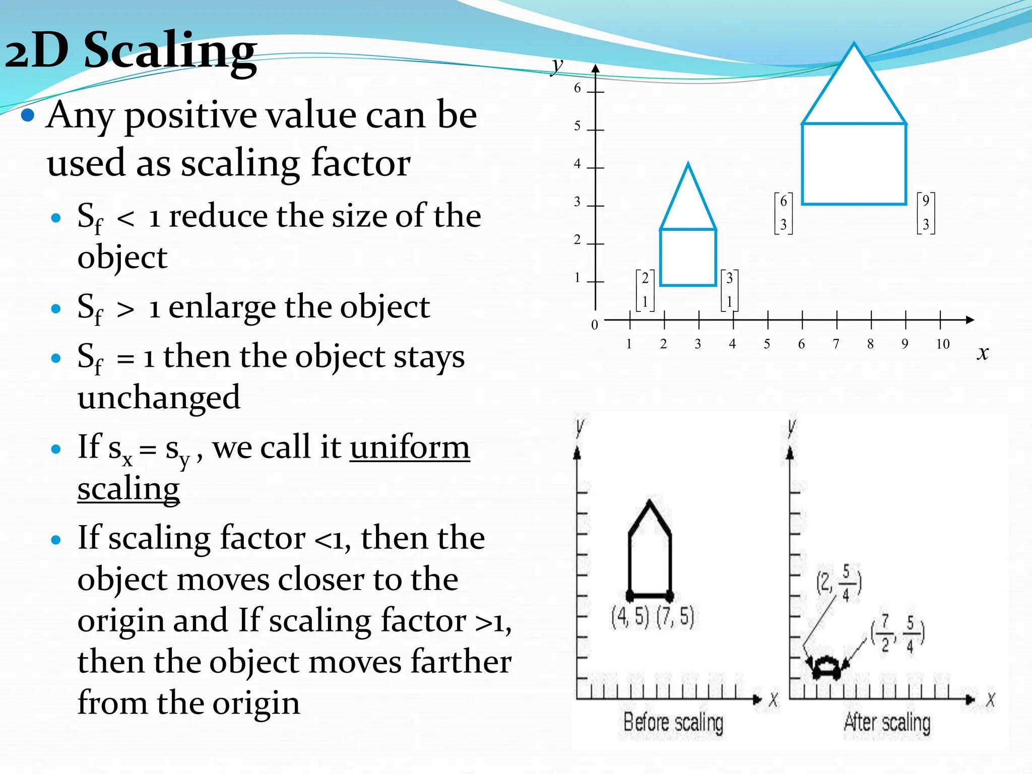
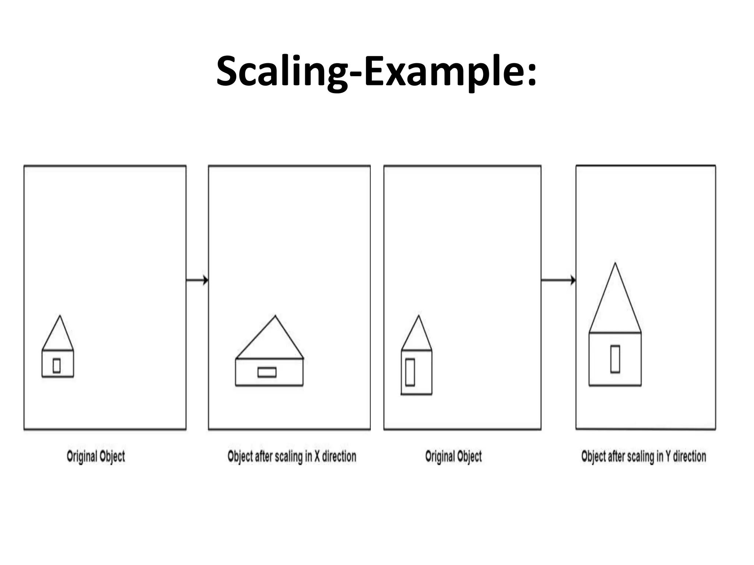
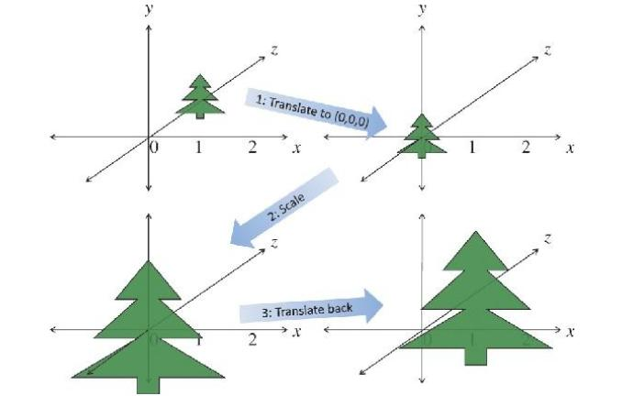
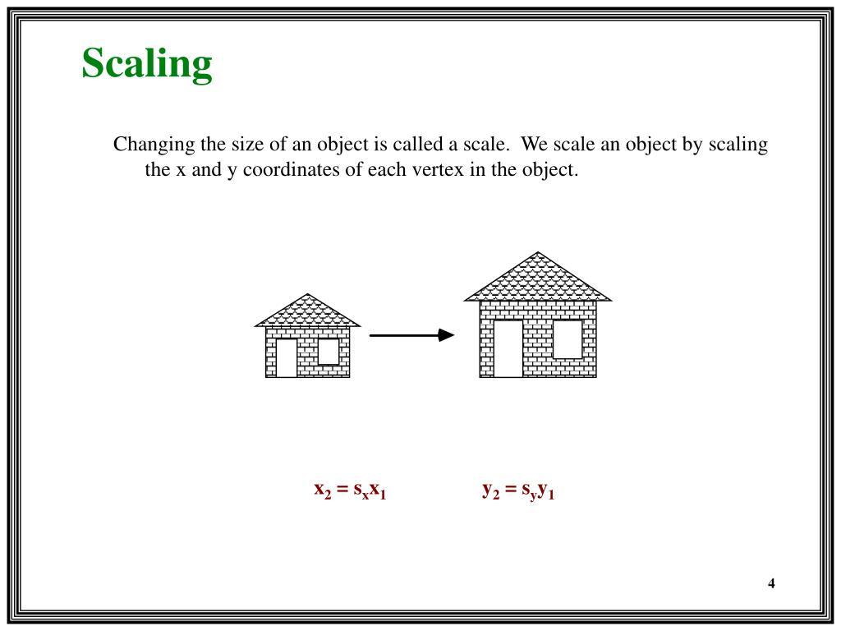
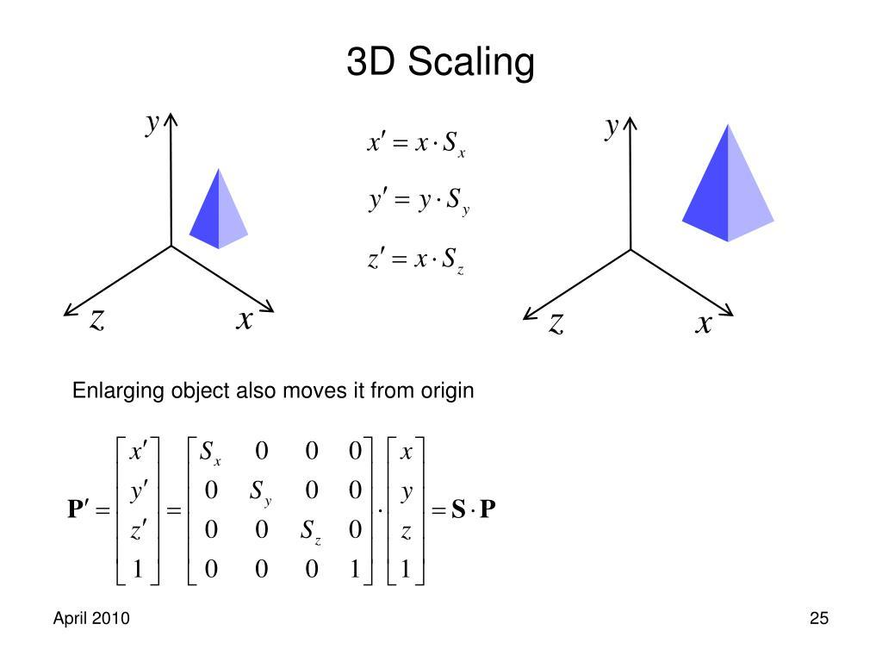

Dilation in CAD
# Source: AI Source: Provided by: [Data Path: Persons Table -> ID Column: 1, Name_En Column: Motasem Essam] -> From: [ChatGPT] on [7/25/2026]
CAD software uses scaling operations to enlarge or reduce designs.
For example, a mechanical component can be scaled by:
$$k=2$$
to create a version twice as large.
Its:
- Shape remains proportional.
- Angles remain unchanged.
- Lengths double.
- Area becomes four times as large.

Real-World Examples
# Source: AI Source: Provided by: [Data Path: Persons Table -> ID Column: 1, Name_En Column: Motasem Essam] -> From: [ChatGPT] on [7/25/2026]
Dilation can be represented by:
- Maps.
- Blueprints.
- Scale models.
- Architectural drawings.
- Enlarged photographs.
- Reduced photographs.
- Microscopic images.
- Telescopic images.
- Computer zoom.
- Engineering models.
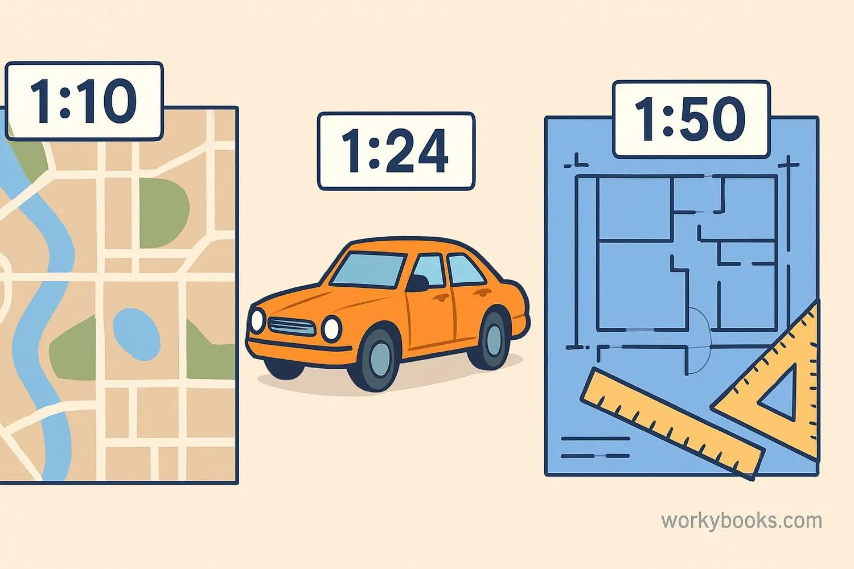
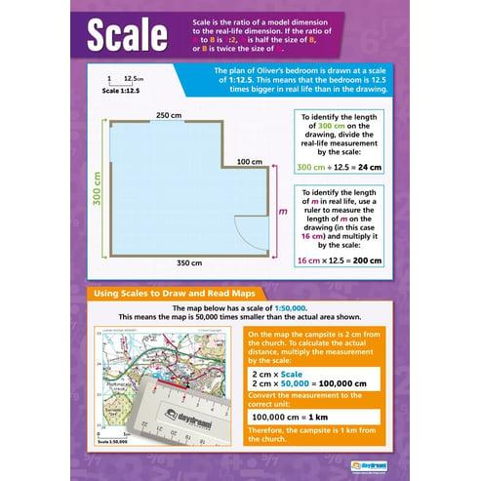
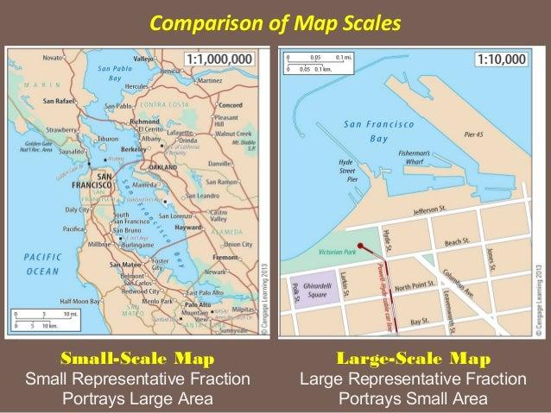

Advantages
# Source: AI Source: Provided by: [Data Path: Persons Table -> ID Column: 1, Name_En Column: Motasem Essam] -> From: [ChatGPT] on [7/25/2026]
Studying dilation helps to:
- Understand similarity.
- Analyze proportional relationships.
- Enlarge and reduce figures.
- Work with scale drawings.
- Transform coordinates.
- Calculate missing dimensions.
- Understand map scales.
- Support architectural design.
- Support engineering models.
- Develop computer graphics.

Limitations
# Source: AI Source: Provided by: [Data Path: Persons Table -> ID Column: 1, Name_En Column: Motasem Essam] -> From: [ChatGPT] on [7/25/2026]
Dilation:
- Changes the size of a figure when $k≠1$.
- Does not preserve side lengths.
- Does not preserve perimeter.
- Does not preserve area.
- Requires a center of dilation.
- Requires a scale factor.
- Can change the position of a figure relative to the center.

Comparison with Other Transformations
# Source: AI Source: Provided by: [Data Path: Persons Table -> ID Column: 1, Name_En Column: Motasem Essam] -> From: [ChatGPT] on [7/25/2026]
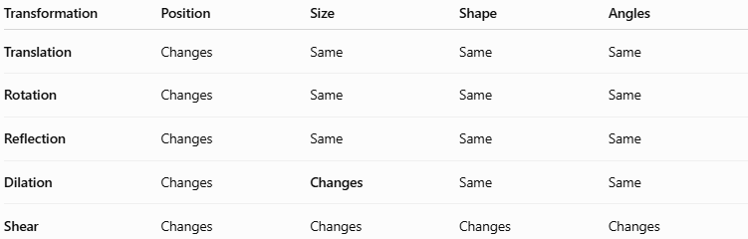
Transformation | Position | Size | Shape | Angles
Translation | Changes | Same | Same | Same
Rotation | Changes | Same | Same | Same
Reflection | Changes | Same | Same | Same
Dilation | Changes | Changes | Same | Same
Shear | Changes | Changes | Changes | Changes
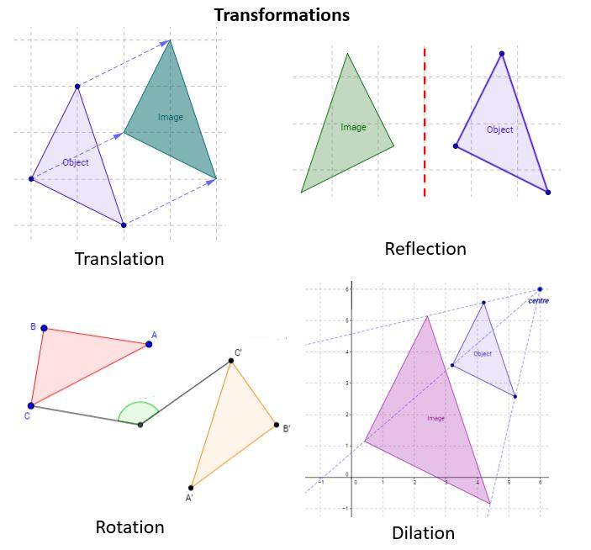
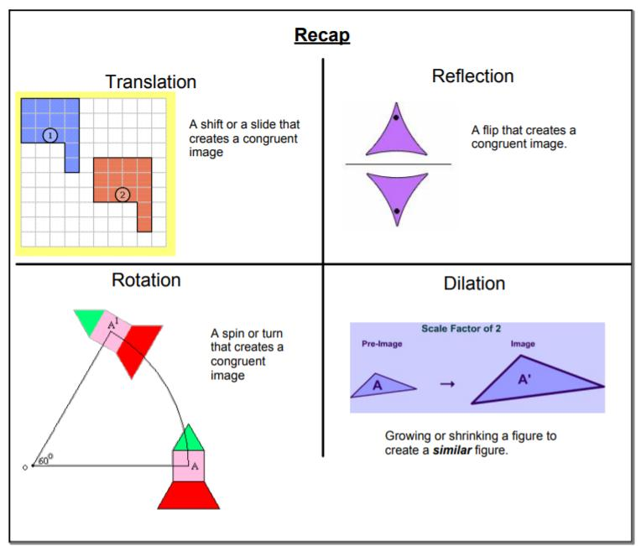
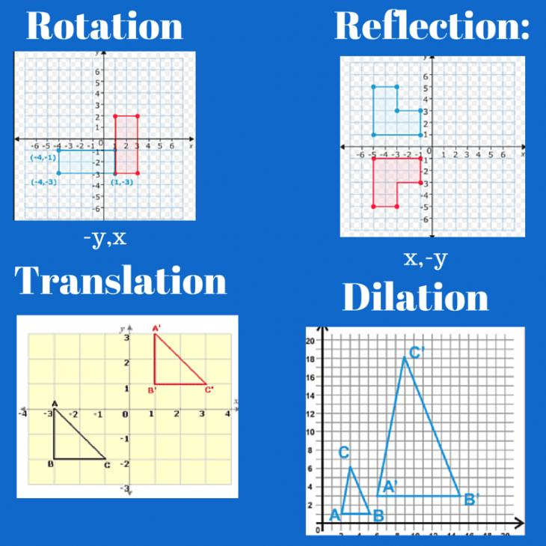
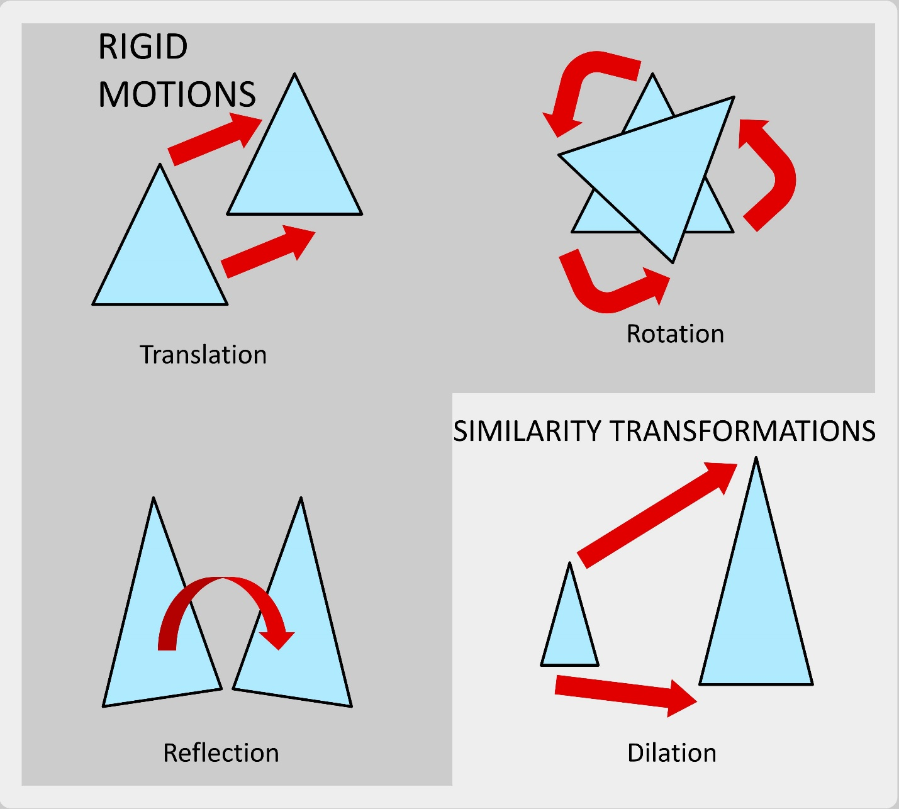
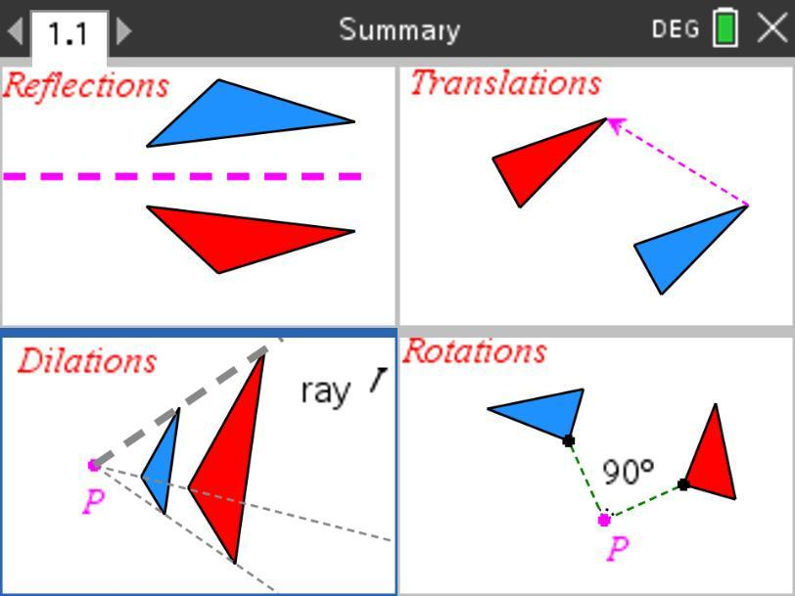

Important Dilation Rules
# Source: AI Source: Provided by: [Data Path: Persons Table -> ID Column: 1, Name_En Column: Motasem Essam] -> From: [ChatGPT] on [7/25/2026]
Center at the Origin
$$\boxed{\left(x , y\right)→\left(kx , ky\right)}$$
Length
$$\boxed{L^{'}=∣k∣L}$$
Perimeter
$$\boxed{P^{'}=∣k∣P}$$
Area
$$\boxed{A^{'}=k^{2}A}$$
Distance from Center
$$\boxed{OA^{'}=∣k∣OA}$$
Similarity
$$\boxed{F∼F^{'}}$$
when the figure is dilated.

Key Points
# Source: AI Source: Provided by: [Data Path: Persons Table -> ID Column: 1, Name_En Column: Motasem Essam] -> From: [ChatGPT] on [7/25/2026]
- Dilation enlarges or reduces a geometric figure.
- It is determined by:
  - A center of dilation
  - A scale factor
- The general relationship is:
$$\boxed{OA^{'}=∣k∣OA}$$
- For a center at the origin:
$$\boxed{\left(x , y\right)→\left(kx , ky\right)}$$
- If:
$$k>1$$
the figure is enlarged.
- If:
$$0<k<1$$
the figure is reduced.
- If:
$$k=1$$
the figure remains unchanged.
- A negative scale factor places the image on the opposite side of the center.
- Dilation preserves:
  - Shape
  - Angle measures
  - Proportions
- Dilation changes:
  - Side lengths
  - Perimeter
  - Area
- The original and dilated figures are similar.
- Dilation is generally not a rigid transformation.

Conclusion
# Source: AI Source: Provided by: [Data Path: Persons Table -> ID Column: 1, Name_En Column: Motasem Essam] -> From: [ChatGPT] on [7/25/2026]
Dilation is a fundamental geometric transformation that enlarges or reduces a figure relative to a fixed center of dilation using a constant scale factor. It preserves the figure's shape, angle measures, and proportions while changing its dimensions.
For a dilation centered at the origin, the coordinate rule is:
$$\boxed{\left(x , y\right)→\left(kx , ky\right)}$$
The corresponding lengths are multiplied by:
$$\boxed{∣k∣}$$
the perimeter is multiplied by:
$$\boxed{∣k∣}$$
and the area is multiplied by:
$$\boxed{k^{2}}$$
Dilation is fundamental to plane geometry, similarity, coordinate geometry, scale drawings, maps, architecture, engineering, CAD, computer graphics, and modeling, where objects frequently need to be enlarged or reduced while preserving their proportions.

